Visualizing Quantitative Information

IMAGE · OTHER MEDIA

Updated on December 7, 2024

Tables Versus Graphs
Numerical data are commonly presented as tables or graphs (Ainsworth, 2021). Tables have the additional advantage of including non-numerical data, as exemplified in Table 1. A typical reason to display numerical data on a table is so that students can extract these values to perform calculations. Moreover, interactive tables on electronic platforms allow the viewer to sort the table entries in ascending or descending order according to the data in a column of choice. The sorted dataset ranks the entries and facilitates comparisons.

Table 1. Hypothetical cities and information about each of their area, median salary, and major industry.

City | Area (km²) | Median salary ($/year) | Major industry
Springfield | 41.10 | 29 000 | Beer
Shelbyville | 30.68 | 25 000 | Turnips
Pallet | 14.40 | 3 000 | Gaming
Elwood | 6.11 | 57 000 | Educational media
Sim | 30.00 | 50 000 | Educational media
Folk | 0.10 | 40 000 | Gaming
Arlen | 25.45 | 30 000 | Propane

While tables are suitable for reading off specific data points, the overall trend of the data may be obscure (Figure 1). Instead, plotting the data on a graph could render the overall shape of the data more apparent, such as the slope (Figure 2), maximum and minimum points, and periodic nature (Ainsworth, 2021).

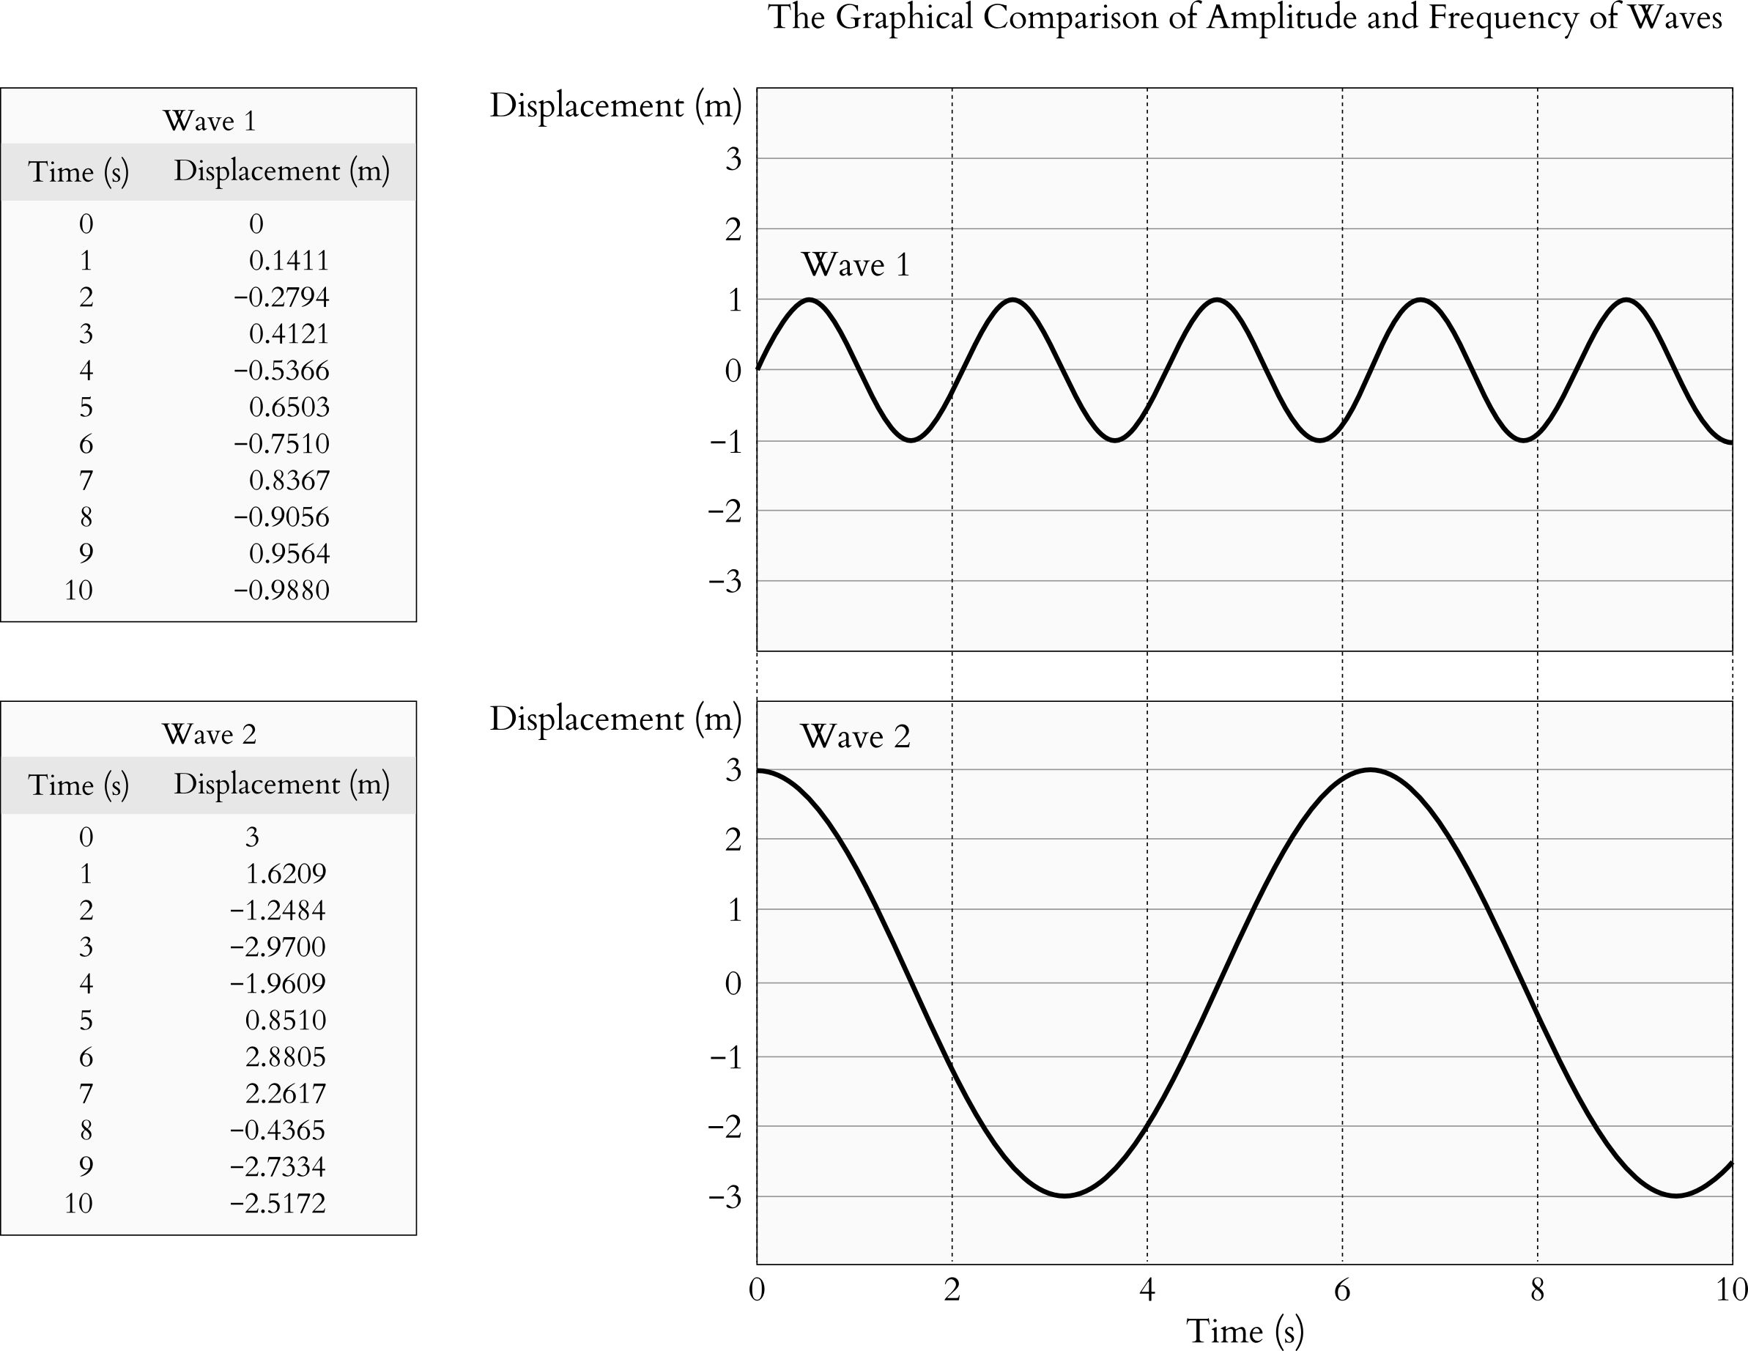
Figure 1. Just by looking at the tables of values alone, it is not immediately obvious that both datasets have a sinusoidal shape and that Wave 1 has lower amplitude and higher frequency than Wave 2. Hence, graphs are better than tables at visualizing trends in data.

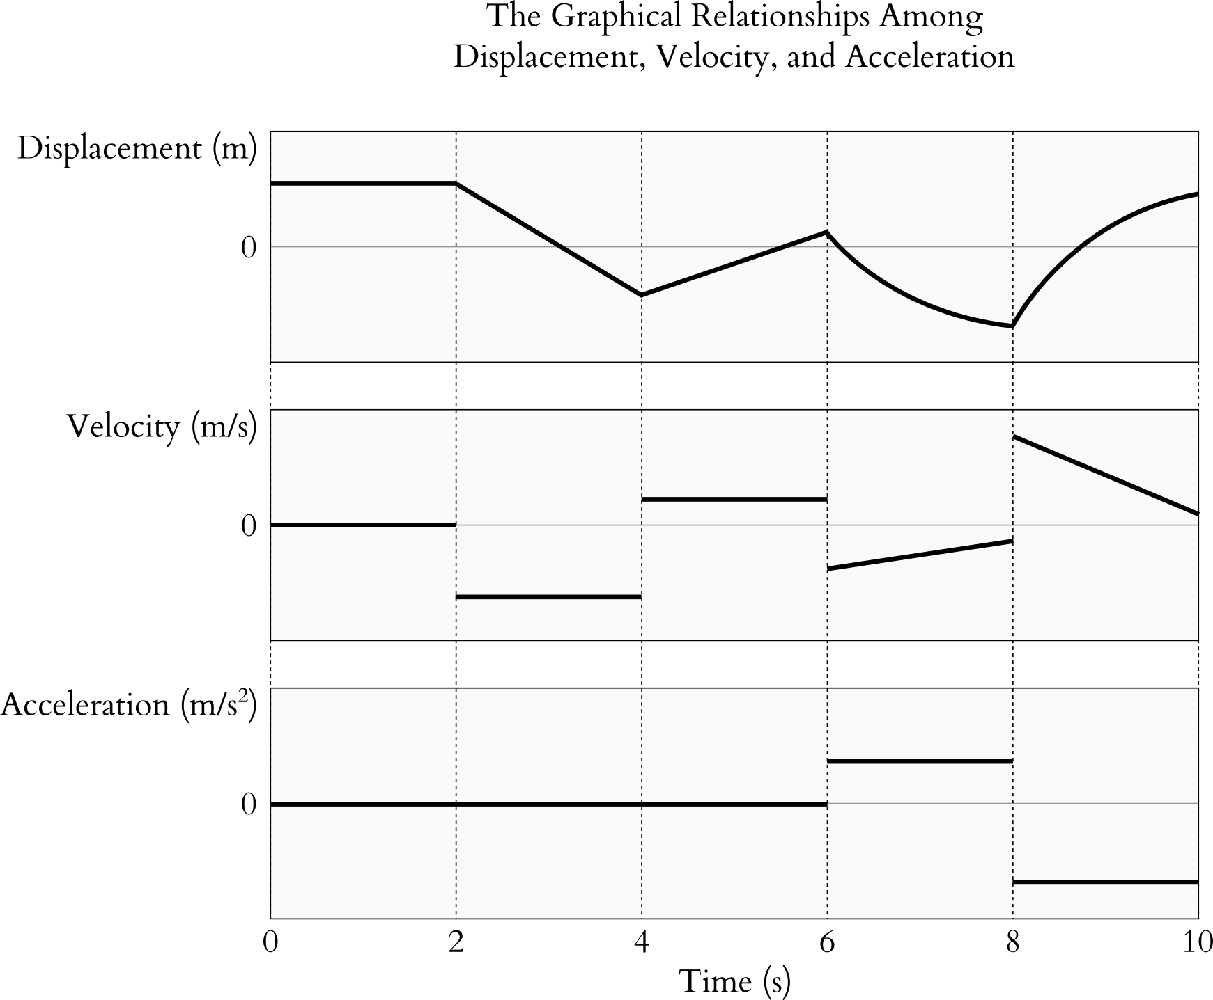
Figure 2. The displacement, velocity, and acceleration of a moving object are graphed as functions of time. The slope of the displacement graph is velocity, and the slope of the velocity graph is acceleration. By seeing the shapes of these graphs, students would be able to make mental connections among these physical quantities.

It may seem that, by convention, discrete data is displayed on a table and continuous data is shown on a graph. However, this is not always the case. In a news report (https://www.youtube.com/watch?v=KfboSuHnL9U) about the mathematical aptitude of Canadian high school students, the math scores, which are discrete data, are plotted on a graph in order to show the decline in math scores as a downward sloping trend (CBC News: The National, 2023). Moreover, the probabilities of continuous statistical distributions are listed in tables so that students can use these values in calculations. Thus, whether to display numerical data on a table or a graph is dependent on the message that is communicated through the data and how students will work with the data.

Other Ways of Quantitative Data Visualization
There are many other ways of representing quantitative information, such as Venn diagrams, pie charts, and discipline-specific data visualization techniques. Venn diagrams illustrate the similarities and differences, whether quantitative or qualitative, of two or three categories (Figure 3). Pie charts show the relative quantification of distinct groups within a whole (Figure 4). Among the various representations, choose those that best fit the instructional messages and learning objectives.

Figure 3. At Thompson Rivers University, students may be enrolled in courses on campus or in Open Learning courses. The Venn diagram shows the count of Indigenous students who took either type of courses in the 2023-2024 fiscal year (Thompson Rivers University, 2024). Students who were dually enrolled in courses on campus and Open Learning are shown as the overlap between the two circles. | 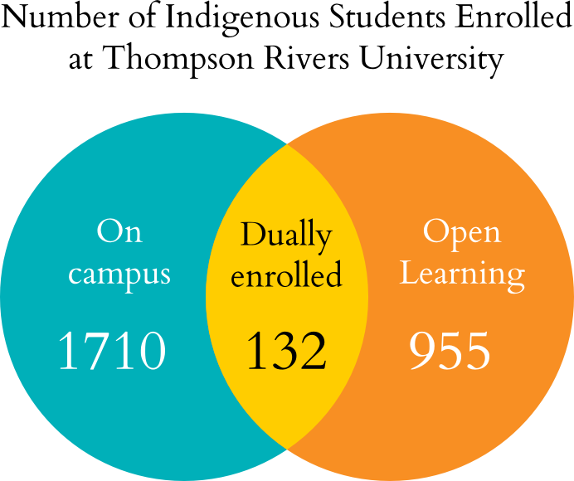

Figure 4. The provinces or territories of origin of domestic students at Thompson Rivers University in the 2023-2024 fiscal year (Thompson Rivers University, 2024) is shown on a pie chart. The whole of the pie refers to the entire domestic student population. The slices of the pie are the percentages of domestic students according to the provinces or territories of origin. | 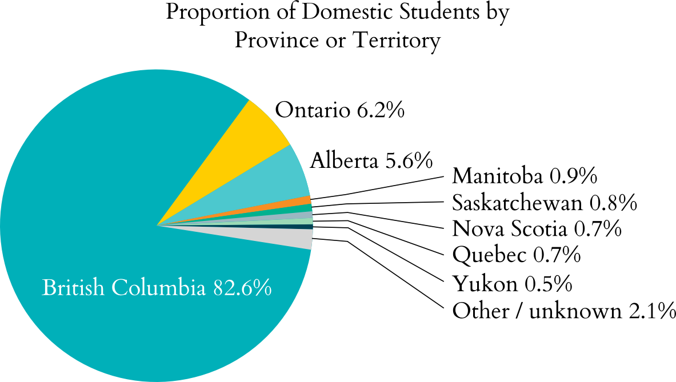

Summary
- Typically, graphs are useful for displaying the overall shape of the data, while tables list the values of specific data points.
- Choosing a method to present numerical data depends on the subject matter.

Media Attributions
Unless otherwise noted, all figures were created by Jung-Lynn Jonathan Yang under a CC BY-NC-ND 4.0 license.

References
Ainsworth, S. (2021). The multiple representations principle in multimedia learning. In R. E. Mayer & L. Fiorella (Eds.), The Cambridge handbook of multimedia learning (pp. 158–170). Cambridge University Press.
CBC News: The National. (2023, December 5). Grade 10 math scores are slipping in Canada, study finds [Video]. YouTube. https://youtu.be/KfboSuHnL9U?si=o7r4NZyZeyY2gGt4
Thompson Rivers University. (2024). Factbook: Fiscal year 2023-24. https://www.tru.ca/__shared/assets/Factbook_2023-2459748.pdf

#Business #Calculus #Image #Other media #Physics

