Student-Generated Drawings

IMAGE

Updated on December 7, 2024

Incorporating drawing as a learning activity to accompany textual information can be helpful for meeting learning outcomes compared to no drawing (Leutner & Schmeck, 2021). According to the drawing principle, the exercise of drawing allows students to engage in generative processing (Leutner & Schmeck, 2021) of text by establishing complex spatial relationships (Fiorella & Mayer, 2021).

Drawing Principle
Student-generated drawings may be a direct or indirect learning objective. In organic chemistry classes, students are asked to draw molecules according to the molecules’ names, as in Examples 1 and 2. Subtle details, such as (R) versus (S) and (E) versus (Z), denote the spatial arrangement of atoms in each molecule.

Example 1. (Learning objective: Draw structural formulas of (R) and (S) stereoisomers.) Sketch the following molecules. Indicate the stereochemistry using bold and dashed bonds.
- (R)-2-bromobutane  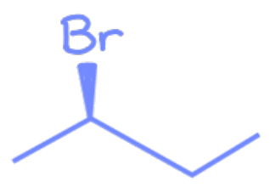 | - (S)-2-bromobutane  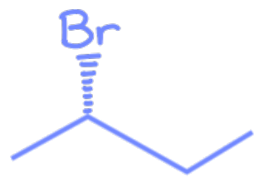

Example 2. (Learning objective: Draw structural formulas of (E) and (Z) alkenes.) Sketch the structure of the following molecules.
- (1E,4E)-1,5-dichloro-1,4-hexadiene  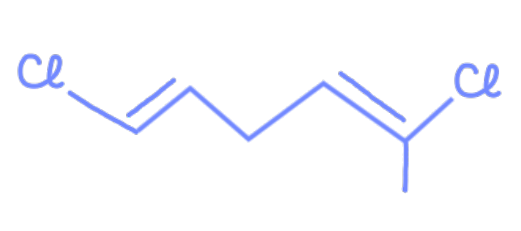 | - (1Z,4E)-1,5-dichloro-1,4-hexadiene  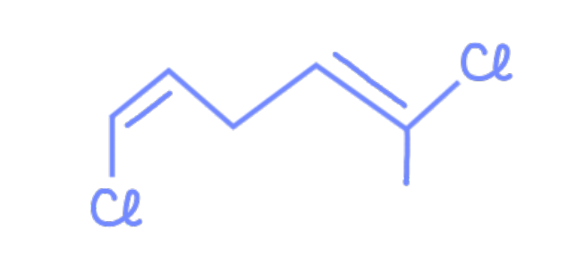
- (1E,4Z)-1,5-dichloro-1,4-hexadiene  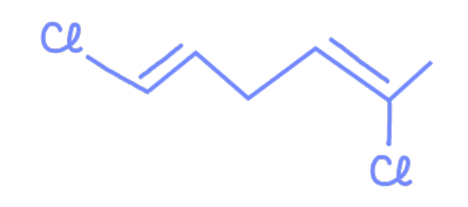 | - (1Z,4Z)-1,5-dichloro-1,4-hexadiene  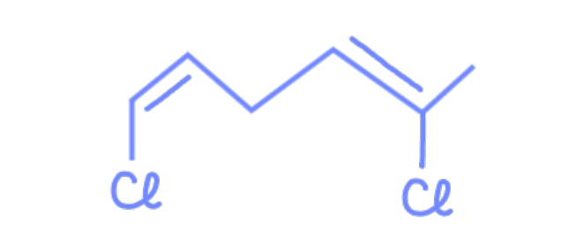

In other instances, students may not be asked directly to draw something, but drawing is an important step in solving the question. The answers to Example 3 are not apparent just by the names of the molecules. Instead, visualizing the molecules allows the recognition of the molecular geometry that contributes to optical activity.

Example 3. (Learning objectives: Identify any asymmetric carbon atoms in a molecule. Classify whether a molecule is optically active.) Identify which of the following molecules are optically active.
- cis-1,3-cyclohexanediol  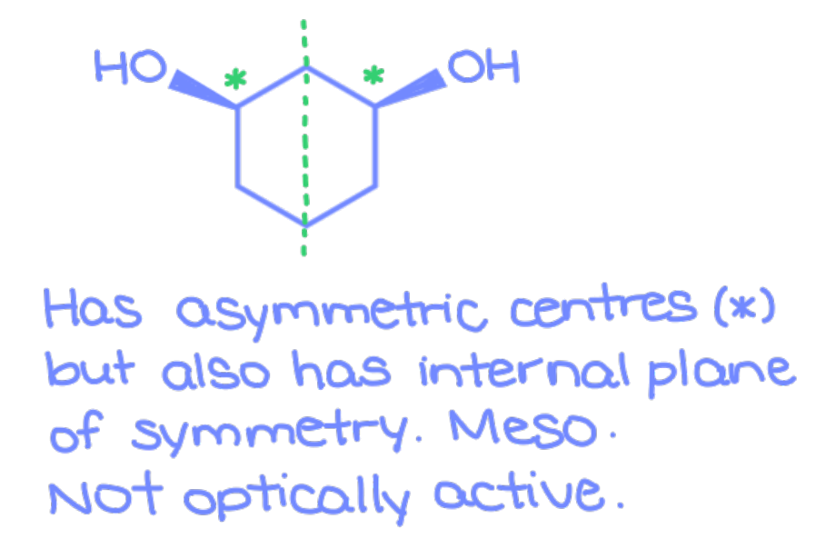 | - trans-1,3-cyclohexanediol  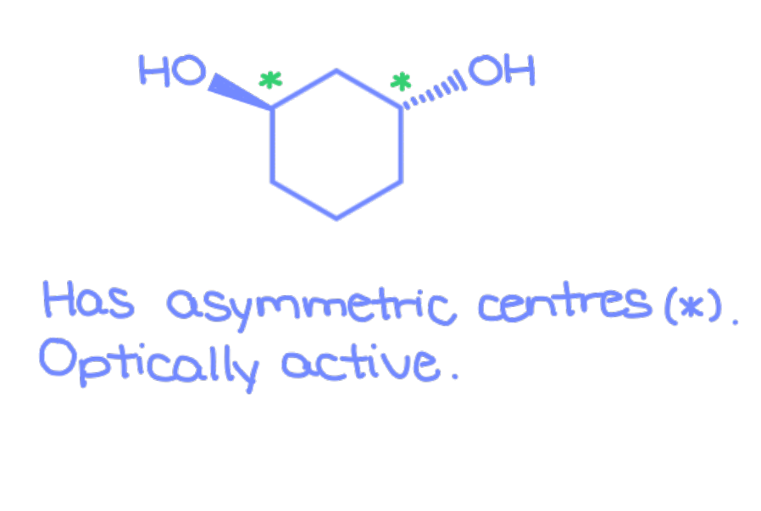
- cis-1,4-cyclohexanediol  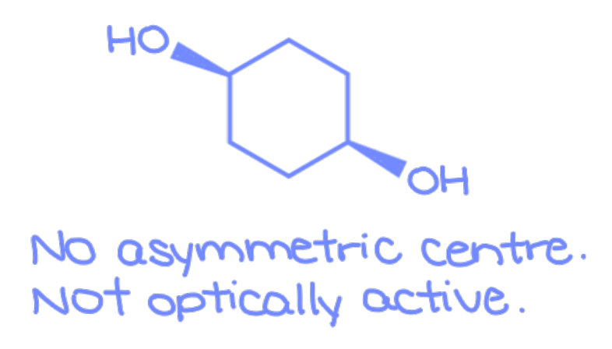 | - trans-1,4-cyclohexanediol  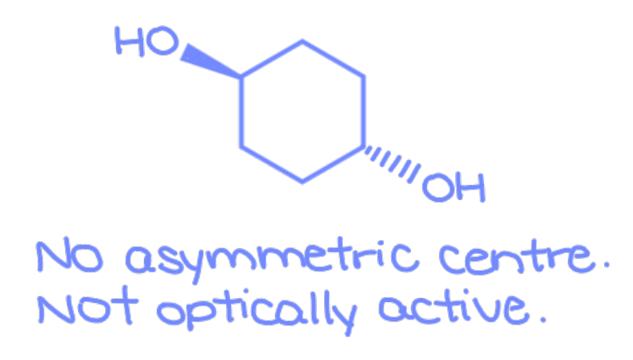

The sketch of quadric surfaces (Example 4) and the free-body diagram (Example 5) are strategies to overcome the split-attention effect by consolidating the given information and the results of intermediate calculations into a single picture.

Example 4. (Learning objectives: Interconvert the equation of a quadric surface among Cartesian, cylindrical, and spherical coordinate systems. Calculate a volume by evaluating a triple integral.) Evaluate the volume of the region enclosed by both x² + y² + z² = 4 and 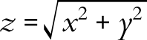.
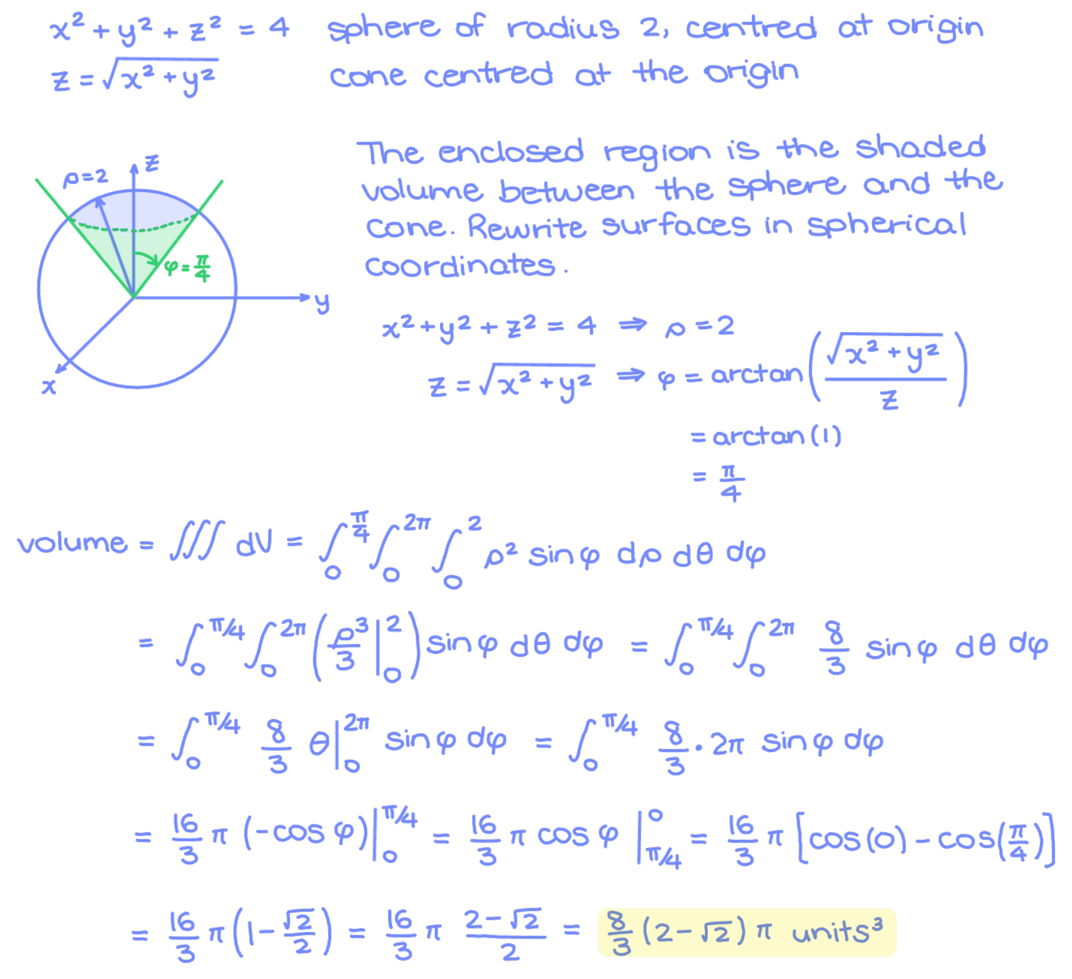

Example 5. (Learning objective: Solve a system at impending motion on an incline.) A box of toys, altogether 5.0 kg, is on a 30° incline. The surface of the incline has a coefficient of static friction μ = 0.10. What is the magnitude of the force, applied parallel to the surface of the incline, that is required to start moving the box upward the incline?
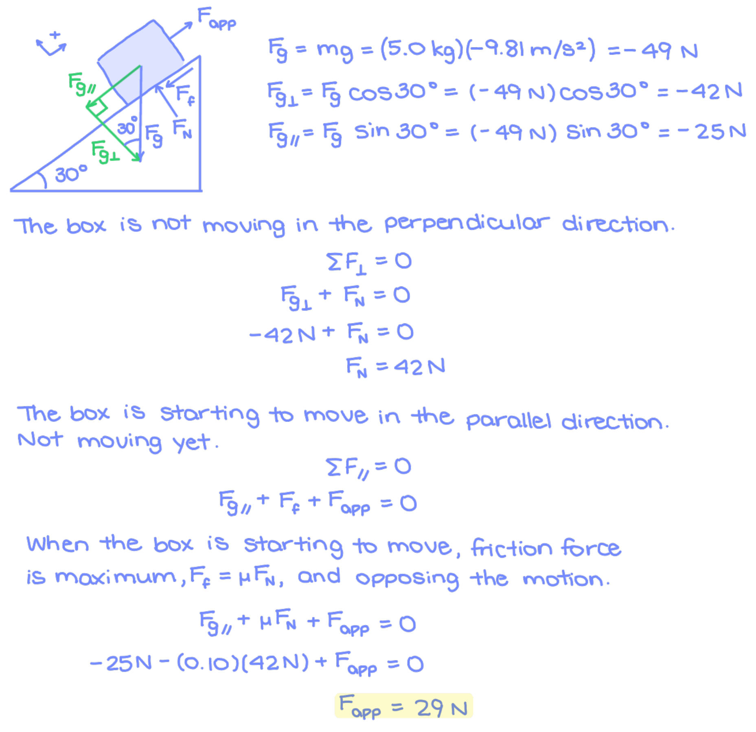

Scaffolding
Yet self-generated drawings also seem to consume cognitive resources and thereby detract from learning (Leopold et al., 2013). Scaffolding may remediate these adverse effects. The scaffold is an incomplete drawing given to students to complete by hand or electronically. HTML5 Package (H5P) drag-and-drop activities, in particular, can scaffold complex drawings and allow students to fill in only the pieces that are directly relevant to the learning objectives. Drag-and-drop involves no act of drawing, but rather, recognizing and organizing objects to the correct location on the drawing. The intent is to de-emphasize the mechanics of drawing and have students focus on the accuracy of the drawings (Leutner & Schmeck, 2021).

A low-tech, offline alternative to H5P drag-and-drop activities is to scaffold drawings as picture files or Microsoft Word documents. Example 6 is a copy-and-paste activity where students draw the cellular organization of the retina. Students have the option of drawing cells from scratch or to use the drawings of cells provided as a scaffold to copy-and-paste into their diagram. The activity provides a scaffold because drawing the intricate details of each cellular appendage is more work for students and does not add to the learning experience. The emphasis of the activity is on the spatial location of cell types among retinal layers, rather than the appearance of the cells.

Example 6. (Learning objective: Describe the organization of cell types into distinct layers in the retina.) Sketch the cellular organization of the retina, and label the retinal layers in your diagram.
Electronically: You may download cartoons of cells as individual PNG files or as the document “celltypesretina.doc”. Copy, paste, and arrange the cells on an image editing software or on Microsoft Word.
By hand: Print out a few hardcopies of the handout “celltypesretina.doc”, cut out the cells and labels of retinal layers, and arrange the cut-outs into a labelled representation of the retina.
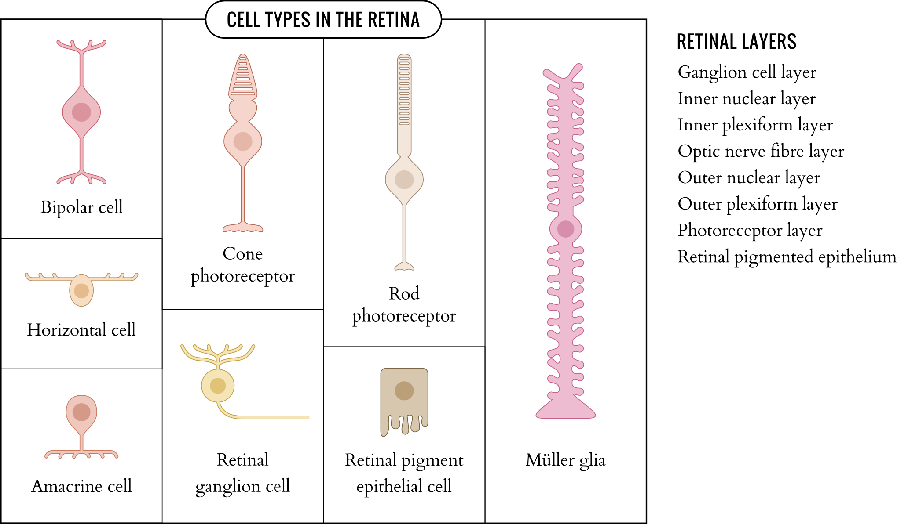
Open-ended question. Sample solution provided.

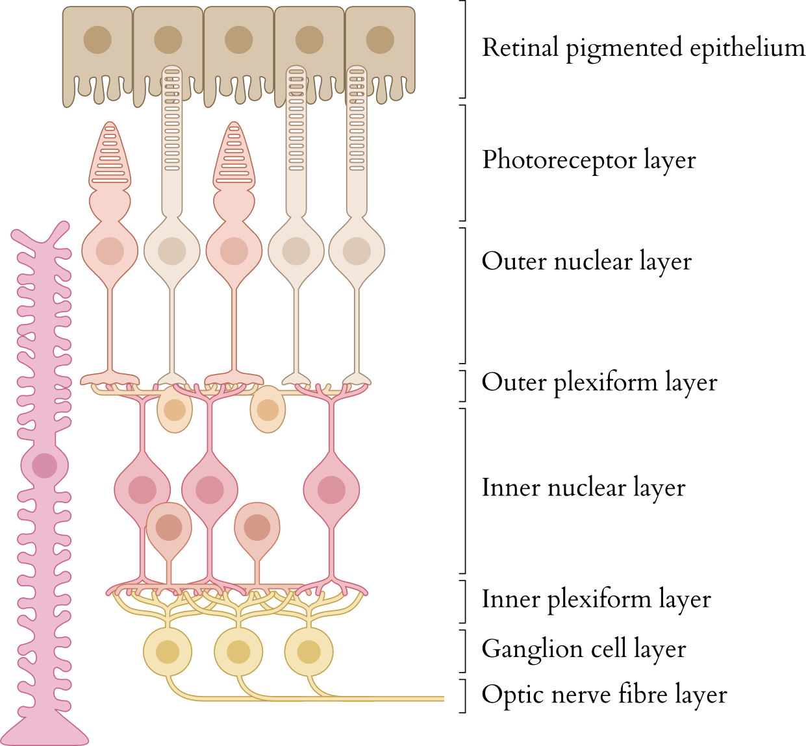

On a technical note, the course developer may consider implementing transparent backgrounds in drawing scaffolds so that images are visible when layered on one another. Transparency can be saved as the file extensions .png (portable network graphic, raster image) or .svg (scalable vector graphic, vector image).

Advances in technology have facilitated the production of elaborate illustrations on tablet computers. However, there does not appear to be consistent differences toward meeting learning objectives whether the drawings were on paper versus on a computer or whether students drew freely versus on scaffolded drawings (Cromley et al., 2020). Overall, the studies reviewed in Leutner & Schmeck (2021) support the notion that student-generated drawing is better for learning than no drawing at all.

Summary
- Remind students to draw as an exercise to build a mental model from textual information in instances where spatial organization is important for meeting the learning objectives.

Media Attributions
Unless otherwise noted, all figures were created by Jung-Lynn Jonathan Yang under a CC BY-NC-ND 4.0 license.

References
Cromley, J. G., Du, Y., & Dane, A. P. (2020). Drawing-to-learn: Does meta-analysis show differences between technology-based drawing and paper-and-pencil drawing? Journal of Science Education and Technology, 29, 216–229. https://doi.org/10.1007/s10956-019-09807-6
Fiorella, L., & Mayer, R. E. (2021). The generative activity principle in multimedia learning. In R. E. Mayer & L. Fiorella (Eds.), The Cambridge handbook of multimedia learning (pp. 339–350). Cambridge University Press.
Leopold, C., Sumfleth, E., & Leutner, D. (2013). Learning with summaries: Effects of representation mode and type of learning activity on comprehension and transfer. Learning and Instruction, 27, 40–49. https://doi.org/10.1016/j.learninstruc.2013.02.003
Leutner, D., & Schmeck, A. (2021). The drawing principle in multimedia learning. In R. E. Mayer & L. Fiorella (Eds.), The Cambridge handbook of multimedia Learning (pp. 360–369). Cambridge University Press.

#Anatomy #Biology #Calculus #Drawing principle
#Image #Organic chemistry #Physics

