Reasons to Use (or to Avoid Using) an Image

IMAGE

Updated on December 14, 2024

Images can be effective for explaining concepts that cannot be described adequately in words alone (Ainsworth & Loizou, 2003). The terms “image,” “picture,” and “graphic” in this post refer to static visual representations that include, but are not limited to, drawings, photographs, microscope images, and screenshots. Choosing images to include in the course material is not trivial because having more pictures does not always mean better learning.

Other types of visual representation that incorporate quantitative information, namely charts, graphs, and tables, are discussed in the post “Visualizing Quantitative Information.” Concept maps are covered in “Concept Mapping as a Review Activity.”

Is the Image Related Directly to Learning Outcomes?
If a concept can be explained clearly in a reasonable amount of written words, then do not include the image (Kalyuga & Sweller, 2021). Avoiding unnecessary images in the course material would lessen the amount of work in course development to make or find media. Another benefit is the reduction of cognitive burden on students to reconcile the information in the images with the rest of the course material (Kalyuga & Sweller, 2021).

Decorative graphics and seductive graphics are not directly relevant to the learning outcomes and should be omitted (Mayer, 2021). The purpose of decorative graphics is to make the educational material look aesthetically pleasing without necessarily being related to the lesson topic. In contrast, seductive graphics are, indeed, related to the lesson topic and are included in educational materials with the intention to engage the learner with interesting information. However, the information is extraneous to the learning outcomes. Despite the advice to avoid decorative or seductive graphics, such media continue to persist in educational resources.

Whether or not an image is helpful for learning also depends on context. When teaching students to read the word “cow,” including a picture of a cow did not help with recognizing the sequence of letters “c-o-w” (Miller, 1937). Therefore, the picture of a cow should be omitted here. However, learning foreign vocabulary was improved when combining the text definition with supporting graphics compared to the text definition alone (Mayer, 2021). Perhaps we can apply this finding to learning technical words, which may seem as unfamiliar as words in a foreign language. Consider using pictures to enhance object recognition, especially in the case of terminology for objects or concrete ideas (Figure 1).

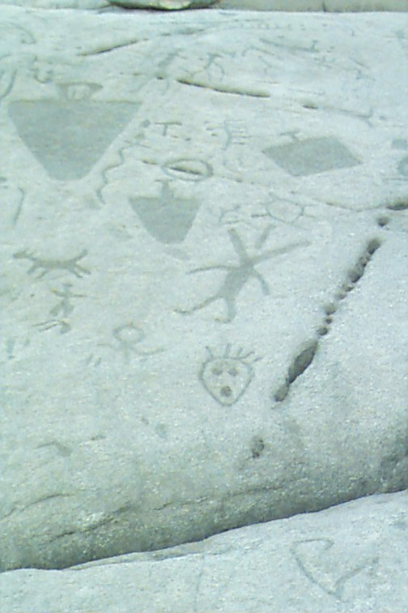 | Figure 1. Petroglyphs are stone carvings from ancient times for recording stories. These petroglyphs were discovered near Peterborough, Ontario (Lone Primate, 2006, CC BY-NC-SA 2.0) (left) and Bella Coola, British Columbia (Guenther, 2007, CC BY-NC-SA 2.0) (below).  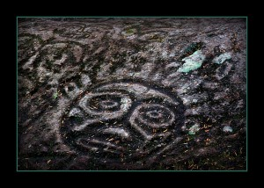

Do the Learning Outcomes and Assessments Require Drawing or Interpreting Images?
If so, then include these types of images. For instance, if students are asked to recognize key artists and artworks that address Northwest Coast Indigenous cultures (Figure 2), then the course material should have examples of these artists and their works so that students can be familiar with them. It can be difficult to describe comprehensively an artwork in words, which is why a visual representation can be effective. Note that Figure 2 does not represent the wide array of artists and artworks and is limited to demonstrating how pictures, such as painting or photography, can be used in educational resources.

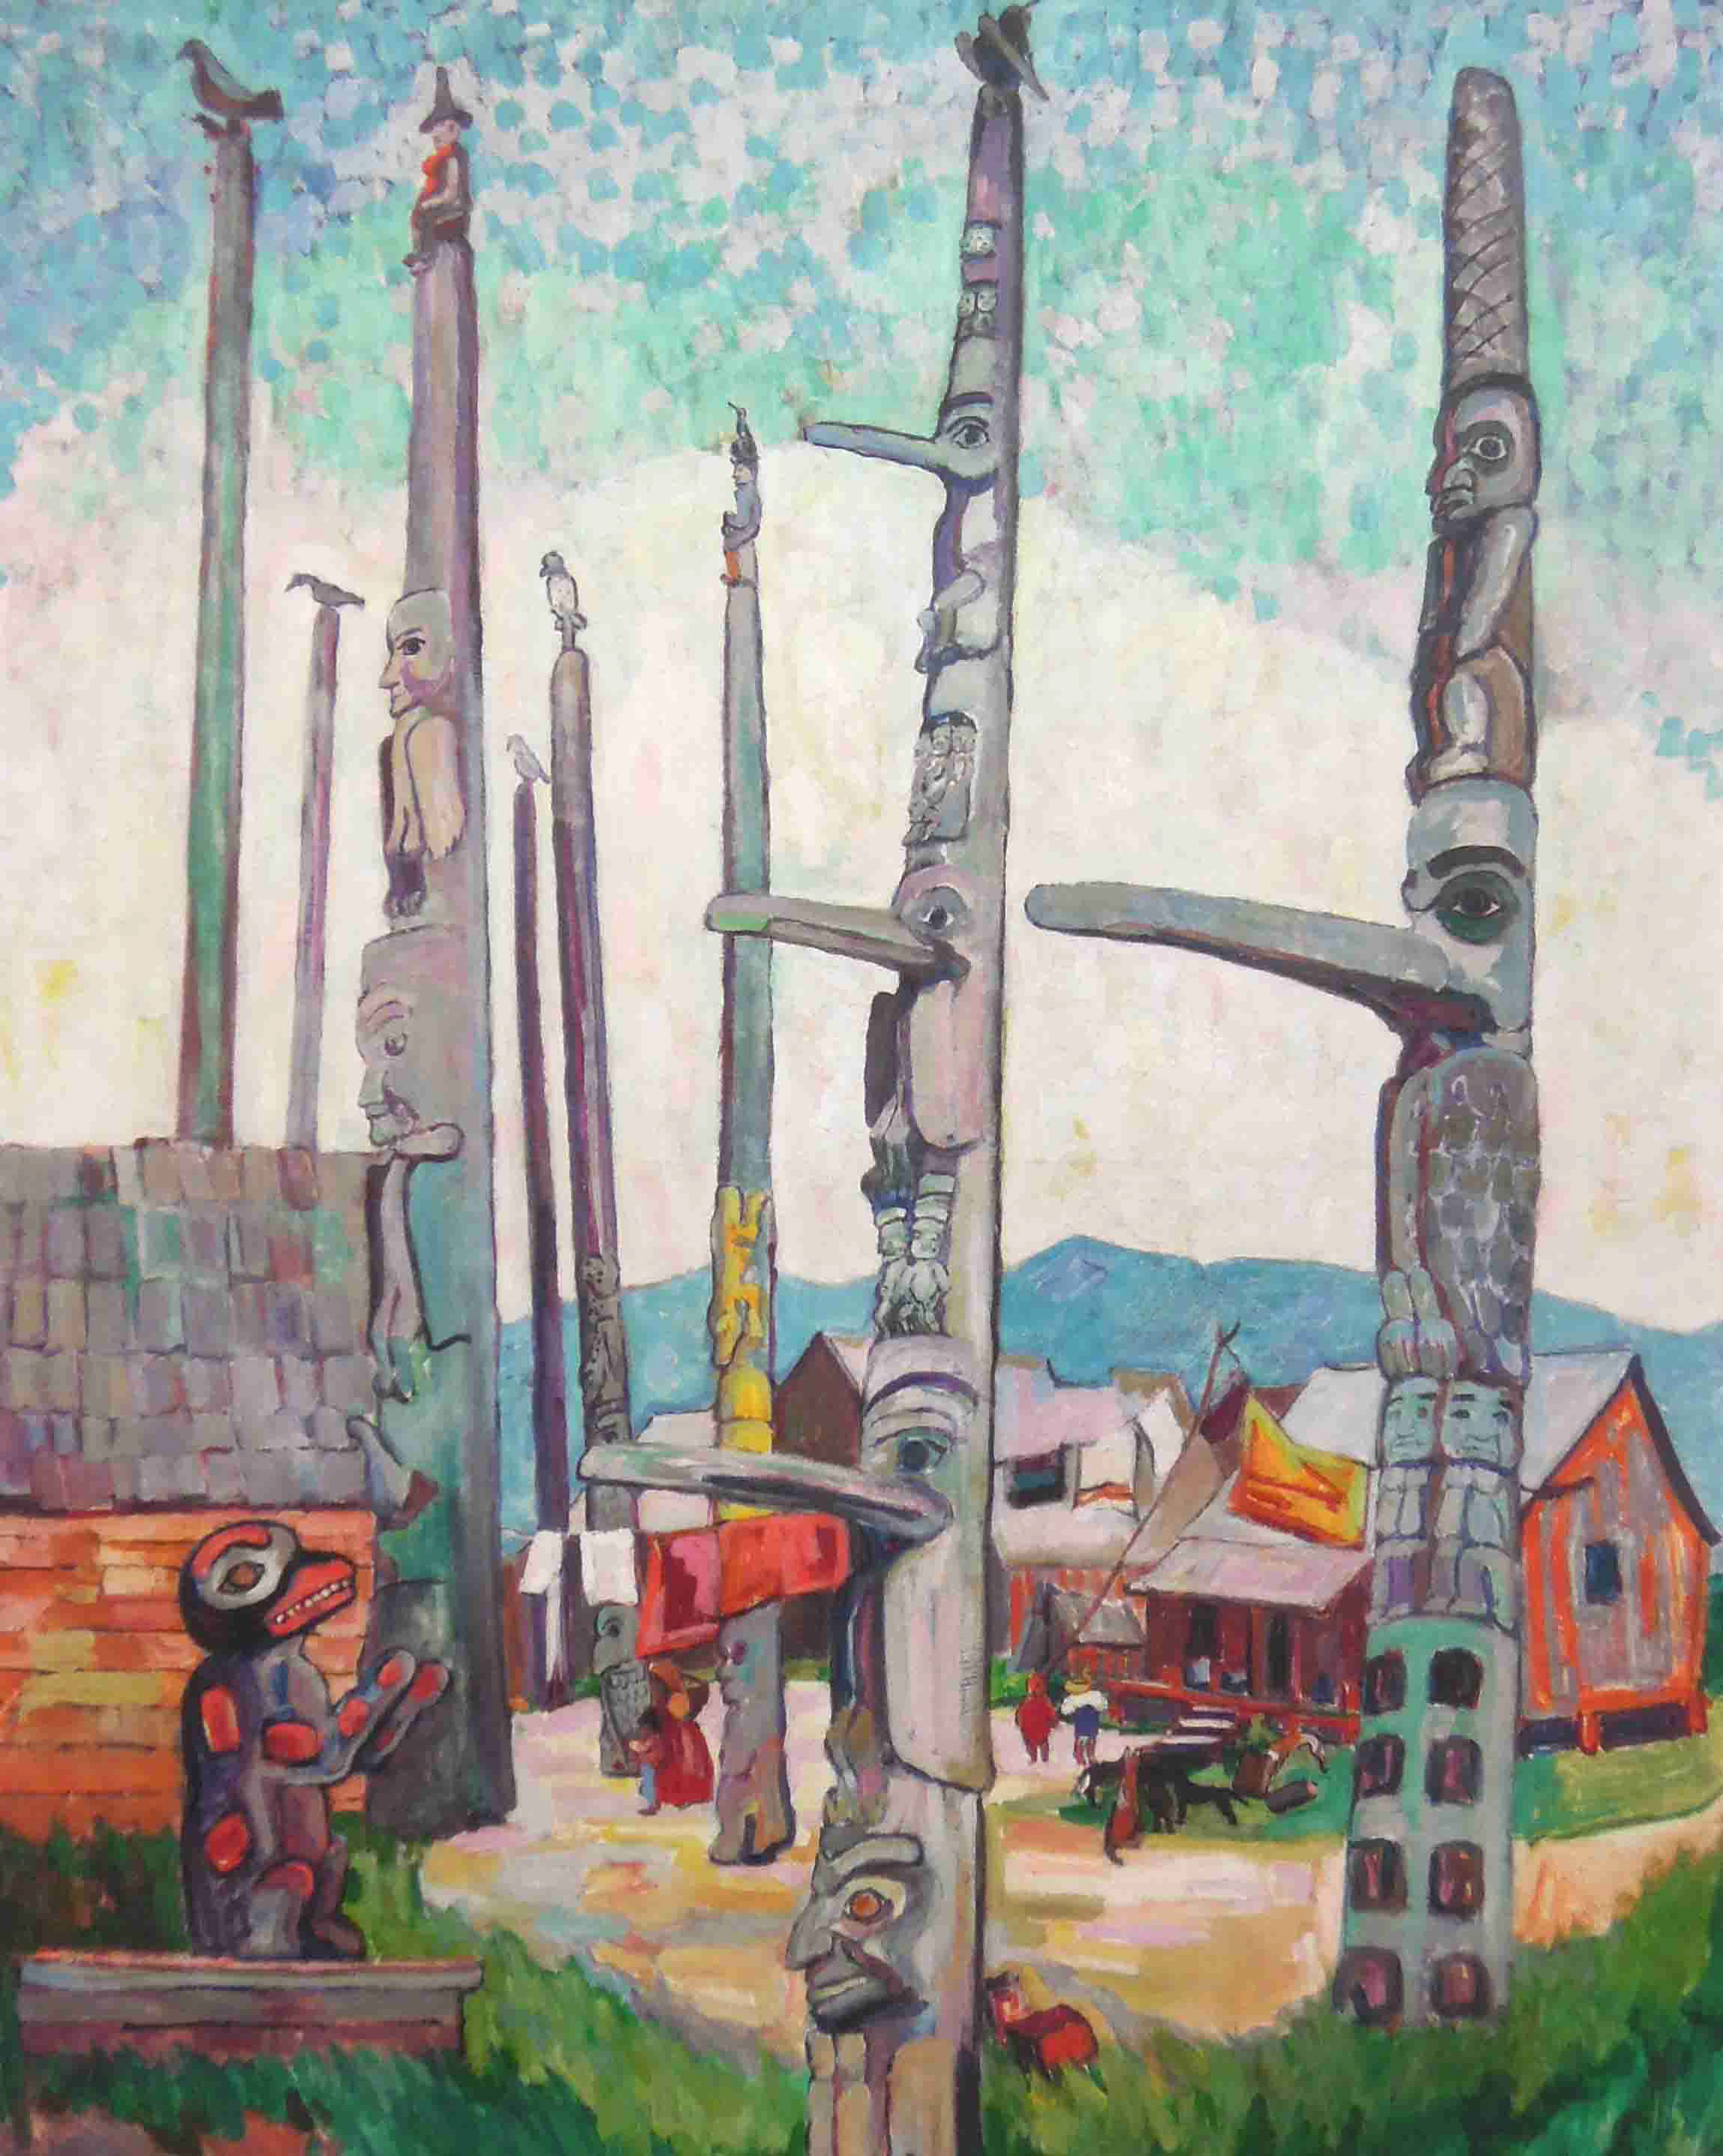 | Figure 2. (Left) “Totem Poles, Kitseukla” painting by Carr (1912, Public Domain). (Below) “Spirit of Haida Gwaii, The Black Canoe” sculpture by Bill Reid (Oberger, 2006, CC BY-SA 3.0).  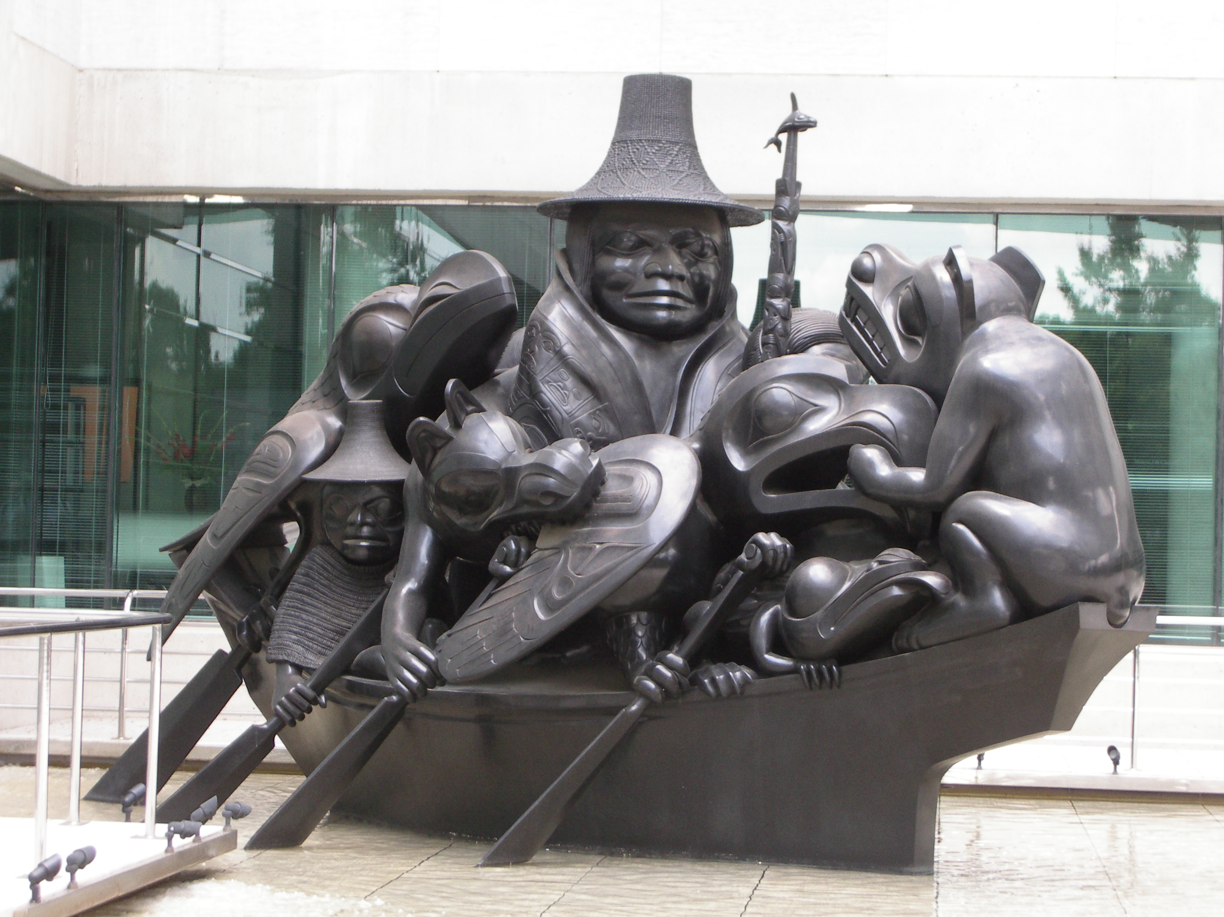

Does the Subject Matter Involve the Arrangement of Multiple Objects in Space?
Learning objectives that depend on spatial reasoning include, but are not limited to, the following subjects:

- Calculus — determine the limits of integration in two- or three-dimensions.
- Anatomy — identify the relative location of bodily organs.
- Organic chemistry — predict reactivity according to the spatial organization of substituents in a molecule.

The course reading and images can work together. The course reading highlights relevant details about the locations of objects and clarifies misinterpretations of the images. The benefit of having images is that multiple objects can be displayed simultaneously in a single image. The image reduces some of the burden on the learner to hold textual information in working memory while constructing the mental model (Fiorella & Mayer, 2021).

Pictorial summaries, when provided to students rather than drawn by students, are especially beneficial for application-based learning objectives (Leopold et al., 2013). Drawing, as an exercise, has been shown to benefit learning. However, pictorial summaries may be helpful alternatives if drawing pictures imposes another cognitive load on students that competes with textual comprehension (Leutner & Schmeck, 2021).

Is the Image Similar To, or Have Redundant Information As, Another Image?
Showing more than one image in spatiotemporal proximity about the same topic, called multiple representation (Ainsworth, 2021), should be avoided unless these images are specified by the learning objectives. Multiple representation requires the viewer to reconcile how each image relates to one another and to the rest of the course, thereby imposing additional cognitive load. If each additional representation repeats the same information in a redundant manner, then a single representation of the subject matter is sufficient.

Organic chemistry is a particular subject that uses multiple representations of molecules to convey nonredundant information (Figure 3). Distinct representations highlight specific aspects of a molecule, such as geometry, chemical reactivity, and thermodynamic stability. Moreover, specific representations may be favoured because of convenience. When learning objectives require students to draw and interpret distinct molecular representations, it is necessary to include these multiple representations in the course material.

A
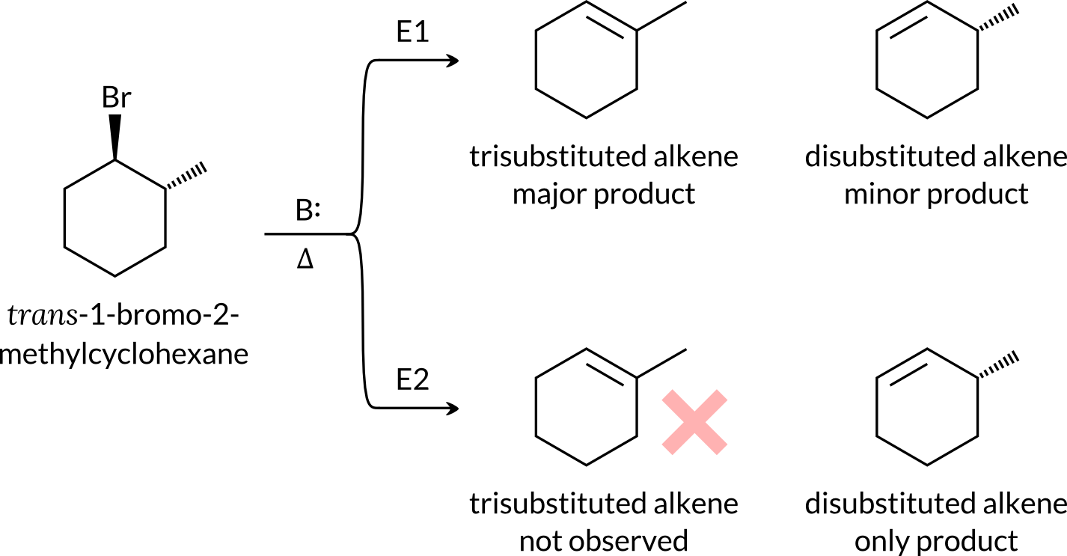

B C
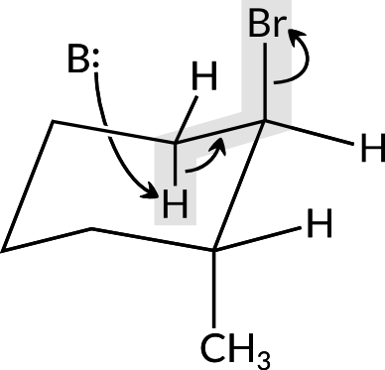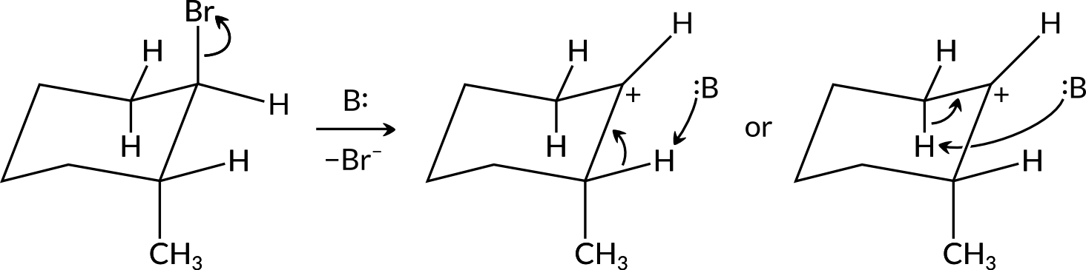
Figure 3. (A) Trans-1-bromo-2-methylcyclohexane reacts by either the E1 or E2 mechanism to give a distinct set of products. The E1 mechanism follows the Zaitsev rule, with most of the products being the more substituted alkene. However, the E2 mechanism appears to violate this rule. The explanation is that the E2 mechanism requires an antiperiplanar configuration of the abstractable hydrogen and leaving group (here, bromine). There is only one hydrogen atom that fits this configuration, which leads to the disubstituted alkene. (B) Students will be able to observe the antiperiplanar configuration (shaded portion) in the chair form, an alternate representation, of trans-1-bromo-2-methylcyclohexane. The structure with bold/dashed bonds is arguably easier to draw by hand than the chair structure, but the configuration of the reacting groups is more apparent in the latter. (C) On the contrary, it is unnecessary to draw another representation of the E1 mechanism because additional representations do not offer more information than the convenient bold/dashed bonds representation.

Is the Image Consistent With the Information in the Course?
Avoid pictures that have typographical errors, factual errors, inconsistencies contrary to the information presented elsewhere in the course material, or irrelevant information to the course. These problems can be difficult to avoid in graphics from open educational resources compared to graphics custom-made for the course content. Figure 4 has an example of a Creative Commons image with minor errors that appears in multiple open educational resources. A possible solution may be editing the graphic, if allowed by copyright rules and technological capabilities, to correct errors or inconsistencies, exclude irrelevant parts of the picture, or fill in relevant details. If editing the graphic is not possible, then the figure caption is an opportunity to inform students of the specific parts of the graphic to correct or disregard.

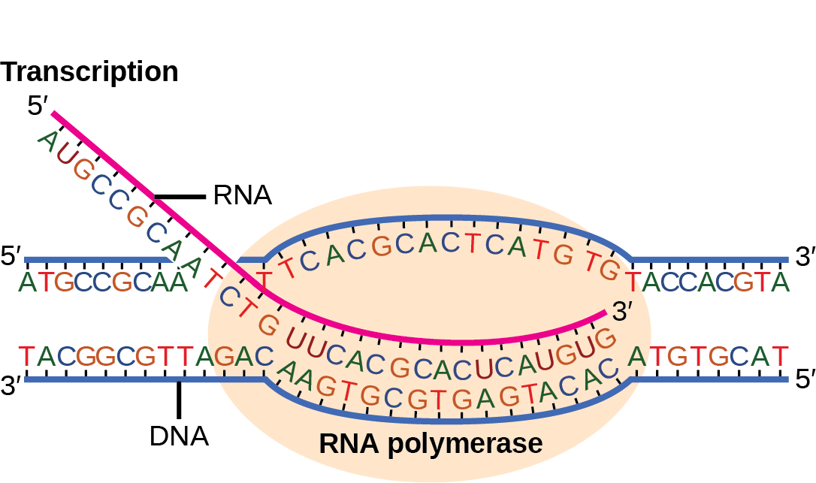
Figure 4. Thymine (T) should not appear in RNA and should, instead, be replaced with uracil (U) (OpenEd CUNY, 2024). The course developer may correct the error on an image-editing software or use the image but alert students by stating the error and the correction in the figure caption. A corrected image may be available after some browsing online, such as in Clark et al. (2024). CC BY 4.0

Is the Image Just…Bad?
Avoid poor-quality graphics (e.g., unlabelled, abstract line-drawings (Schmeck et al., 2014)) that have limited ability to improve learning. Search for other images with better quality, edit the poor-quality image, or make a new image.

Summary
- If a concept can be explained sufficiently in words, then accompanying images are not necessary.
- Images should be consistent with the overall information presented in the course and have direct relevance to the learning objectives, such as recognizing objects, interpreting visual information, illustrating spatial relationships, or summarizing concepts.
- Avoid multiple representation, unless the representations are relevant to the learning objectives.
- Do not include images that are solely for decoration or to entice the reader.

Media Attributions
Unless otherwise noted, all figures were created by Jung-Lynn Jonathan Yang under a CC BY-NC-ND 4.0 license.
- Figure 1:
  - Left: “Petroglyphs, two” by Lone Primate (2006), via Flickr, is used under a CC BY-NC-SA 2.0 license.
  - Right: “Petroglyph - Thorsen Creek” by Lloyd Guenther (2007), via Flickr, is used under a CC BY-NC-SA 2.0 license.
- Figure 2:
  - Left: “Totem Poles, Kitseukla” by Emily Carr (1912), via Obelisk Art History, is in the public domain.
  - Below: “Bill Reid Haida Gail 01” by Boberger (2006), via Wikimedia Commons, is used under a CC BY-SA 3.0 license.
- Figure 4: “Messenger RNA is a copy of…” by Rice University (n.d.), via OpenEd CUNY, is used under a CC BY 4.0 license.

References
Ainsworth, S. (2021). The multiple representations principle in multimedia learning. In R. E. Mayer & L. Fiorella (Eds.), The Cambridge handbook of multimedia learning (pp. 158–170). Cambridge University Press.
Ainsworth, S., & Loizou, A. (2003). The effects of self-explaining when learning with text or diagrams. Cognitive Science, 27(4), 669–681. https://doi.org/10.1207/s15516709cog2704_5
Carr, E. (1912). Totem poles, kitseukla [Painting]. Obelisk Art History. Retrieved October 19, 2024, from https://www.arthistoryproject.com/artists/emily-carr/totem-poles-kitseukla
Clark, M. A., Douglas, M., & Choi, J. (2024). 15.2 Prokaryotic transcription. OpenStax. Retrieved October 19, 2024, from https://openstax.org/books/biology-2e/pages/15-2-prokaryotic-transcription
Fiorella, L., & Mayer, R. E. (2021). Principles for reducing extraneous processing in multimedia learning: Coherence, signaling, redundancy, spatial contiguity, and temporal contiguity principles. In R. E. Mayer & L. Fiorella (Eds.), The Cambridge handbook of multimedia learning (pp. 185–198). Cambridge University Press.
Guenther, L. (2007). Petroglyph - Thorsen Creek [Photograph]. Flickr. https://www.flickr.com/photos/9958155@N05/781032812
Kalyuga, S., & Sweller, J. (2021). The redundancy principle in multimedia learning. In R. E. Mayer & L. Fiorella (Eds.), The Cambridge handbook of multimedia learning (pp. 212–220). Cambridge University Press.
Leopold, C., Sumfleth, E., & Leutner, D. (2013). Learning with summaries: Effects of representation mode and type of learning activity on comprehension and transfer. Learning and Instruction, 27, 40–49. https://doi.org/10.1016/j.learninstruc.2013.02.003
Leutner, D., & Schmeck, A. (2021). The drawing principle in multimedia learning. In R. E. Mayer & L. Fiorella (Eds.), The Cambridge handbook of multimedia learning (pp. 360–369). Cambridge University Press.
Lone Primate. (2006). Petroglyphs, two [Photograph]. Flickr. https://www.flickr.com/photos/loneprimate/87049703/in/photolist-8G9Qy-8G9QX-a3Z77-gxCjj-ivcet-jeCUY-jeCWL-jeCYt-mLQeU-mQarb-mYrqh-LNN2i-MrsSp-2c1ZQY-32FdF2-34hfgv-34mNqd-34mNvC-4q9LqW-4Hx3xF-4LEXKx-4LEYfD-5geXfU-5ihVQD-5vPL5y-5ysyFB-5GBvMf-5WMa6a-5WRpCf-62815y-6gfZCR-6gfZCX-6kfiZp-6m6nin-6paZDB-6CGmjd-6DVMMW-6NewEL-6RbK4i-6SCFnn-6SGJvs-6TF7eQ-9wdsSU-8m2w27-ceysWL-aEYif3-dnKHNx-7W1TYn-dnKP85-aeX9J4-ch7XDQ
Mayer, R. E. (2021). The multimedia principle. In R. E. Mayer & L. Fiorella (Eds.), The Cambridge handbook of multimedia learning (pp. 145–157). Cambridge University Press.
Miller, W. A. (1937). The picture crutch in reading. The Elementary English Review, 14(7), 263–264, 274. https://www.jstor.org/stable/41381040
Oberger, B. (2006). Spirit of Haida Gwaii, the Black Canoe [Photograph]. Wikimedia Commons. https://commons.wikimedia.org/w/index.php?curid=2551770
Rice University. (n.d.). Prokaryotic transcription. OpenEd CUNY. Retrieved October 19, 2024, from https://opened.cuny.edu/courseware/lesson/677/student
Schmeck, A., Mayer, R. E., Opfermann, M., Pfeiffer, V., & Leutner, D. (2014). Drawing pictures during learning from scientific text: Testing the generative drawing effect and the prognostic drawing effect. Contemporary Educational Psychology, 39(4), 275–286. https://doi.org/10.1016/j.cedpsych.2014.07.003

#Biology #Canadian history #Image #Organic chemistry

