Concept Mapping as a Review Activity

IMAGE

Updated on December 4, 2024

According to the mapping principle, people learn deeply when they translate complex word-based information into a combined word- and visuospatial format (Adesope et al., 2021; Fiorella & Mayer, 2021). The collaborative mapping principle goes further to suggest that concept mapping can be a collaborative activity with other learners (Adesope et al., 2021).

A typical concept map has concepts, represented as labelled and/or pictorial nodes, joined to other concepts by lines or arrows into a web-like representation (Adesope et al., 2021; Fiorella & Mayer, 2021). Below are examples of concept maps for organic chemistry (Figure 1) and vector calculus (Figure 2).

Concept maps are helpful for:

- keeping account of current knowledge
- integrating new knowledge
- seeing the nature of the relationships among concepts, such as the hierarchy, distance, and directionality (cause-and-effect) of the relationships (Adesope et al., 2021; Fiorella & Mayer, 2021)

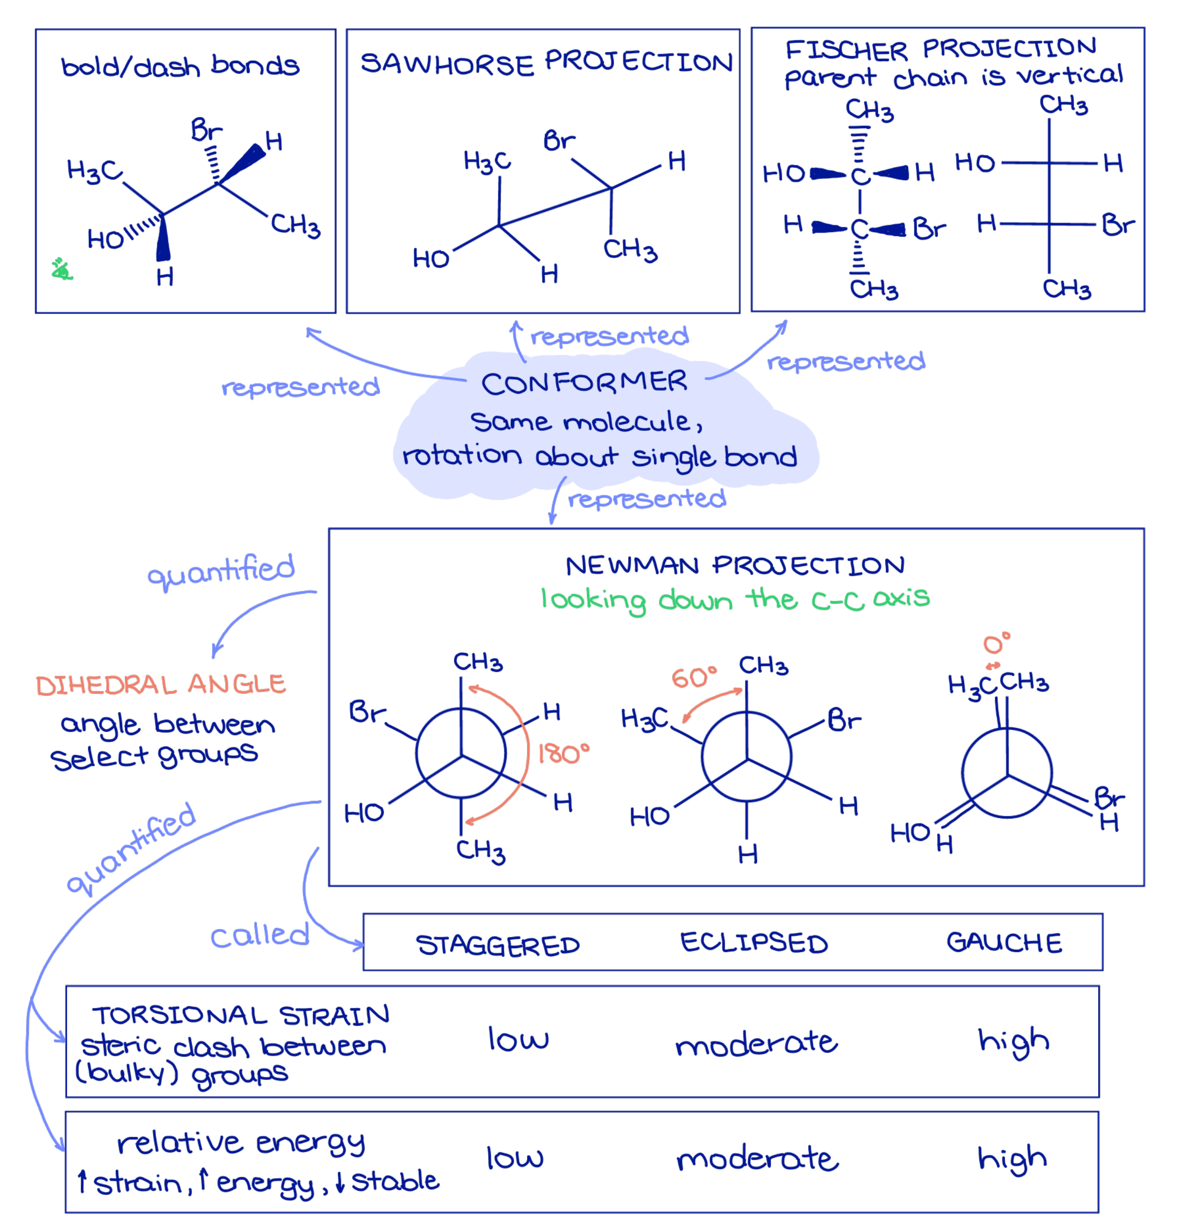
Figure 1. The main theme, molecular conformation, appears as a shaded figure in the middle of the concept map and branches off into the various representations of molecular conformation. The same example molecule relates the distinct representations among the structural formula with bold and dash bonds, sawhorse projection, and Fischer projection. The Newman projection carries additional details, such as quantitative information, about conformers.

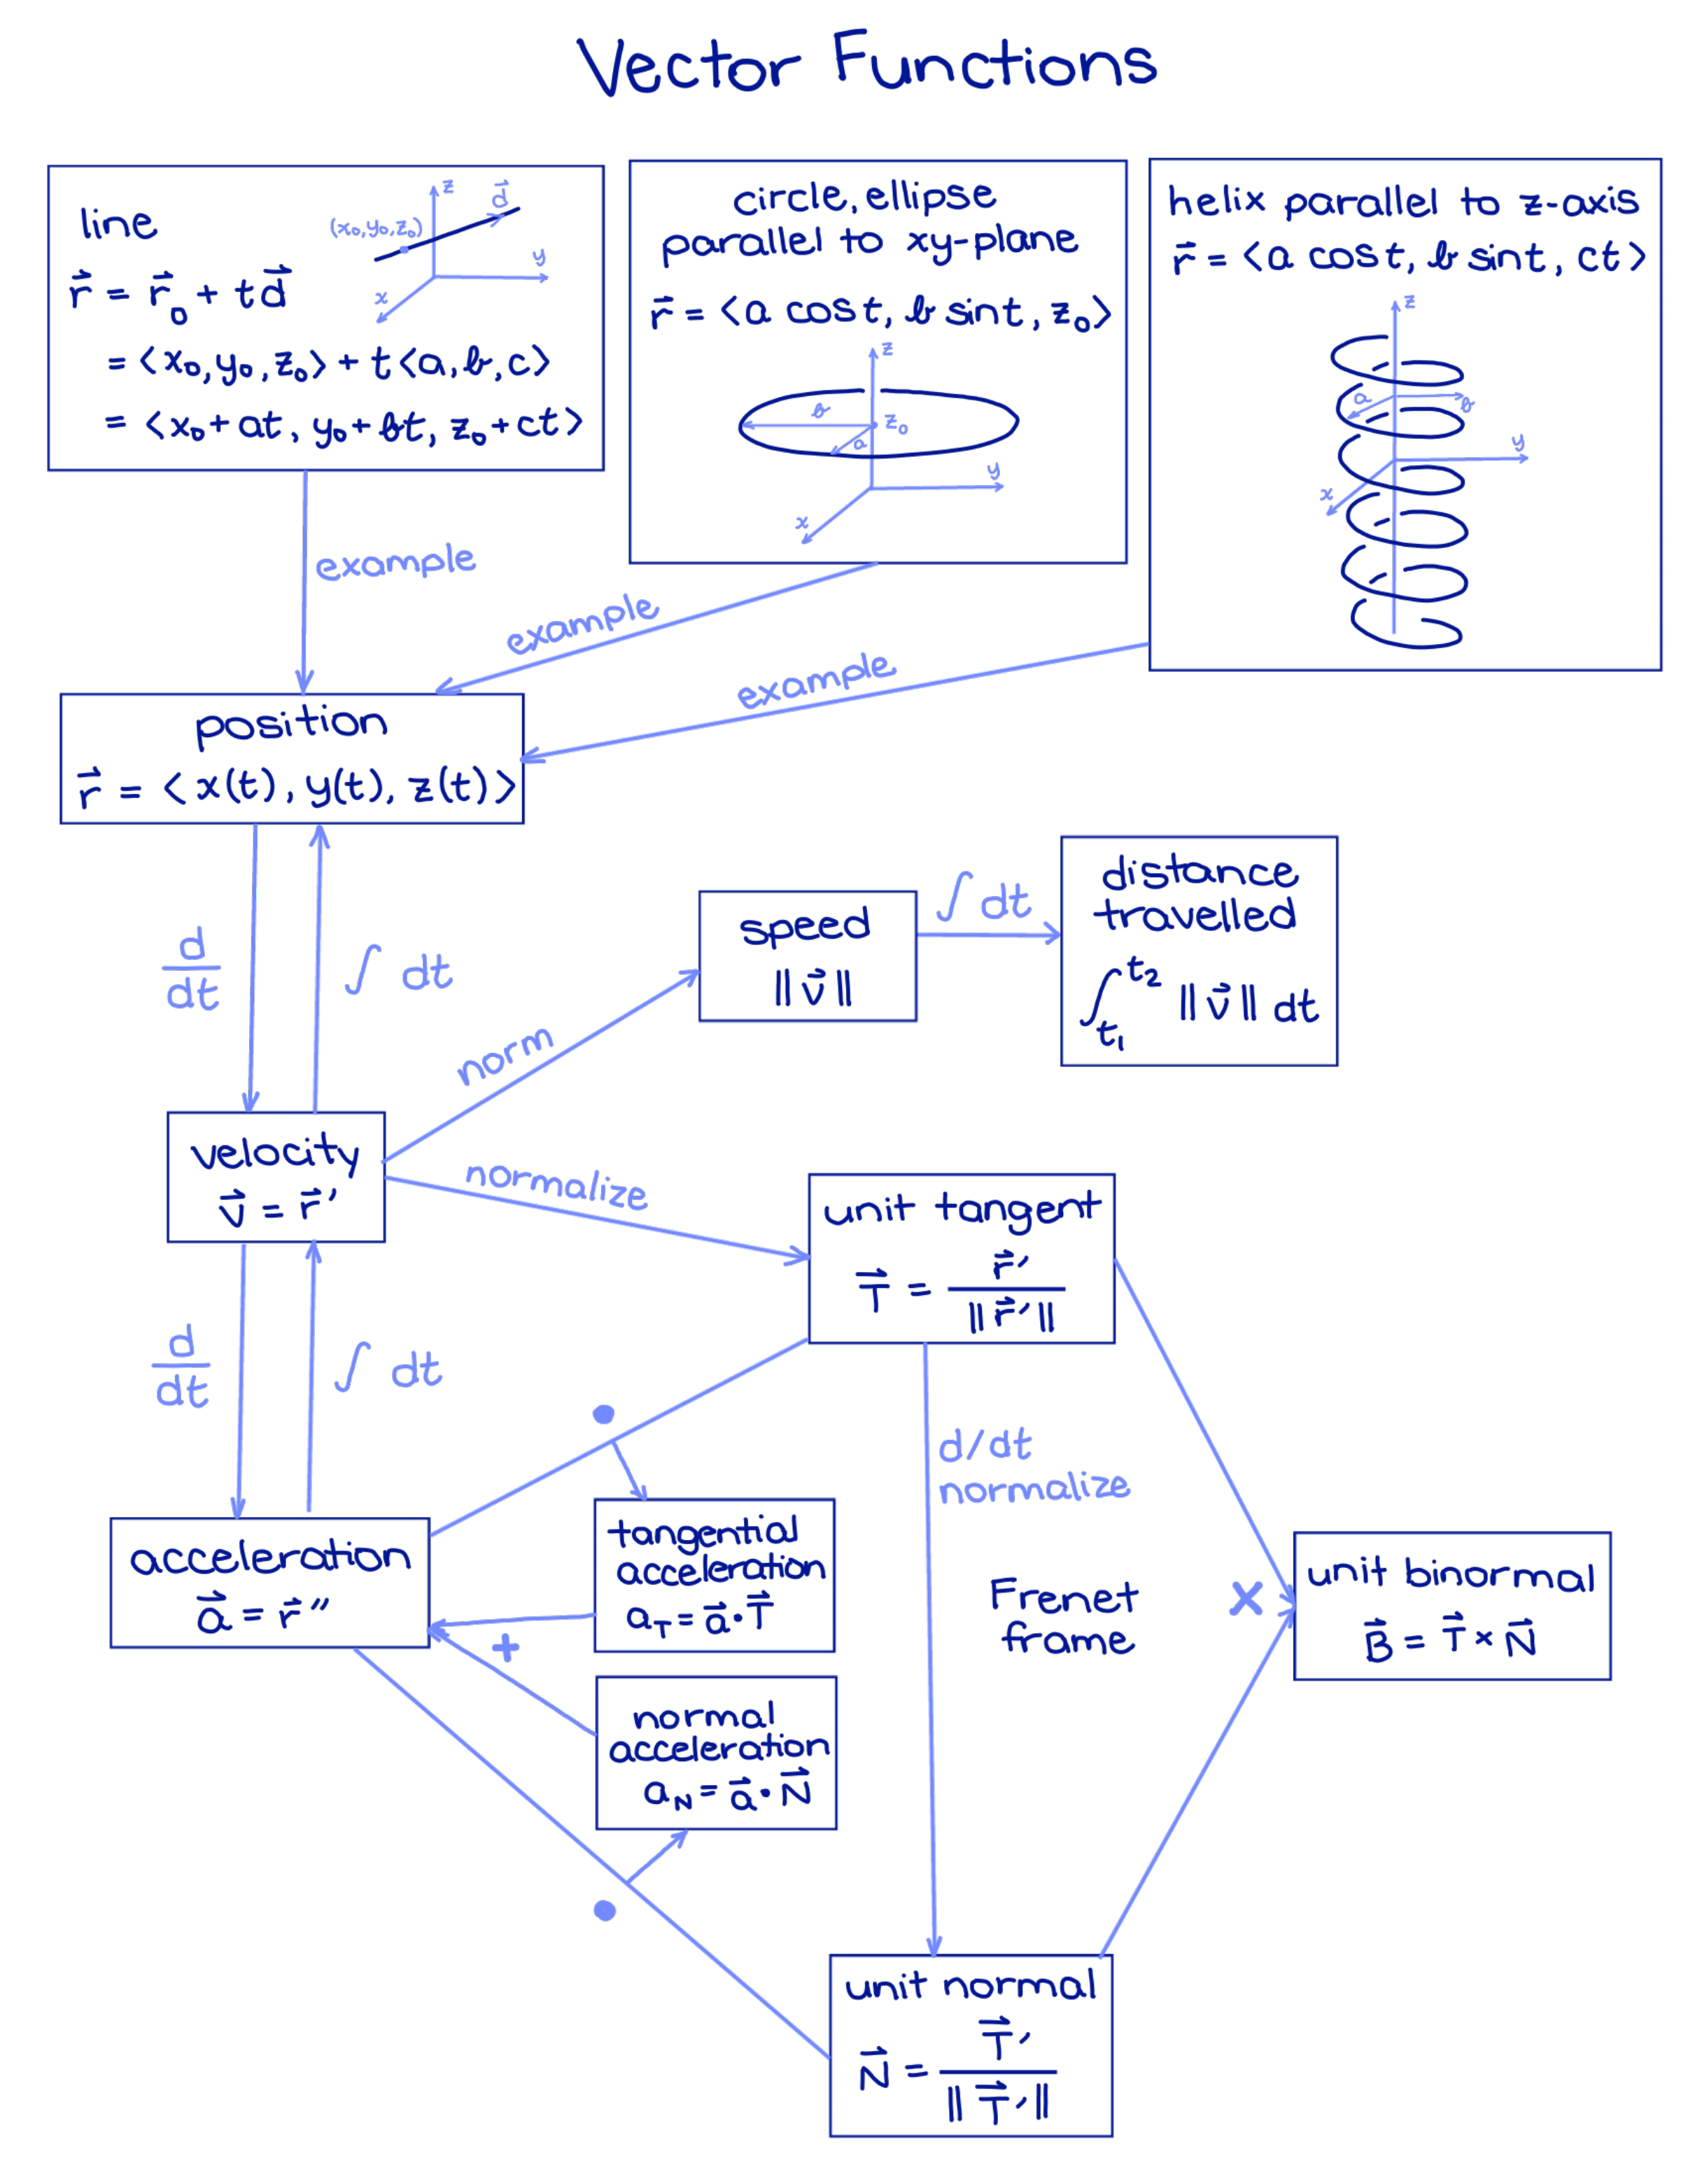
Figure 2. The concept map of vector calculus has each mathematical quantity within a box, and the boxes are connected by arrows that denote the path to move from one quantity to another. The directionality of each path is important because the associated mathematical operations depend on the direction.

Interestingly, student-made concept maps tend to be more effective for learning than studying instructor-generated maps (Schroeder et al., 2018). Seemingly, most of the research on the benefits of mapping is about students making maps, either individually or collaboratively, rather than maps that are provided by the instructor (Adesope et al., 2021). The role of the instructor would be to encourage students to concept map at strategic points in a course (Adesope et al., 2021), such as when reviewing for exams.

Summary
- Encourage students, individually or in groups, to make concept maps as a way to integrate distinct topics in a course.

Media Attributions
Unless otherwise noted, all figures were created by Jung-Lynn Jonathan Yang under a CC BY-NC-ND 4.0 license.

References
Adesope, O. O., Nesbit, J. C., & Sundararajan, N. (2021). The mapping principle in multimedia learning. In R. E. Mayer & L. Fiorella (Eds.), The Cambridge handbook of multimedia learning (pp. 351–359). Cambridge University Press.
Fiorella, L., & Mayer, R. E. (2021). The generative activity principle in multimedia learning. In R. E. Mayer & L. Fiorella (Eds.), The Cambridge handbook of multimedia learning (pp. 339–350). Cambridge University Press.
Schroeder, N. L., Nesbit, J. C., Anguiano, C. J., & Adesope, O. O. (2018). Studying and constructing concept maps: A meta-analysis. Educational Psychology Review, 30, 431–455. https://doi.org/10.1007/s10648-017-9403-9

#Calculus #Collaborative mapping principle #Image
#Organic chemistry #Mapping principle

