Improve the Use of Images

IMAGE

Updated on December 13, 2024

When incorporating an image into educational material, the first step is to evaluate whether the image is relevant to the learning objectives and has non-redundant information. Having decided to use an image, there are additional details to think about to improve communication through the image. The self-explanatory aspect of each image is especially important in Open Learning because students navigate the educational materials on their own, with minimal guidance from an instructor to interpret each image.

Integrating Text With Image
Instructional split-attention occurs when learners have to mentally integrate information that is presented disparately in space (or in time) (Ayres & Sweller, 2021). If multiple sources of information are unintelligible in isolation, then there is split-attention (Ayres & Sweller, 2021). The split-attention effect is detrimental to learning because mentally integrating information consumes cognitive resources (Ayres & Sweller, 2021). The spatial contiguity principle suggests that we can minimize the split-attention effect by putting text and images close together (Ayres & Sweller, 2021).

Separating an image from the relevant information in the main text can be a form of split-attention. Consequently, students may need to look for connections back and forth between the main text and the image in order to integrate the disparate sources of information (Fiorella & Mayer, 2021). Therefore, in the course reading, the image should be in spatial proximity to the location in the main text where the image is discussed.

The figure caption is another way to bring together text and visual information. In fact, BCcampus requires detailed captions for all images. The caption field houses the textual information that is needed for interpreting the image but is not relevant enough to the overall lesson to be in the main text.

Text and image can be brought even closer by physically integrating words and graphics together, such as in the form of a labelled diagram (Fiorella & Mayer, 2021) (Figure 1). Put the label close to the relevant part of the picture to help learners hold both the textual and visual representations in working memory and build text-visual connections (Mayer, 2021).

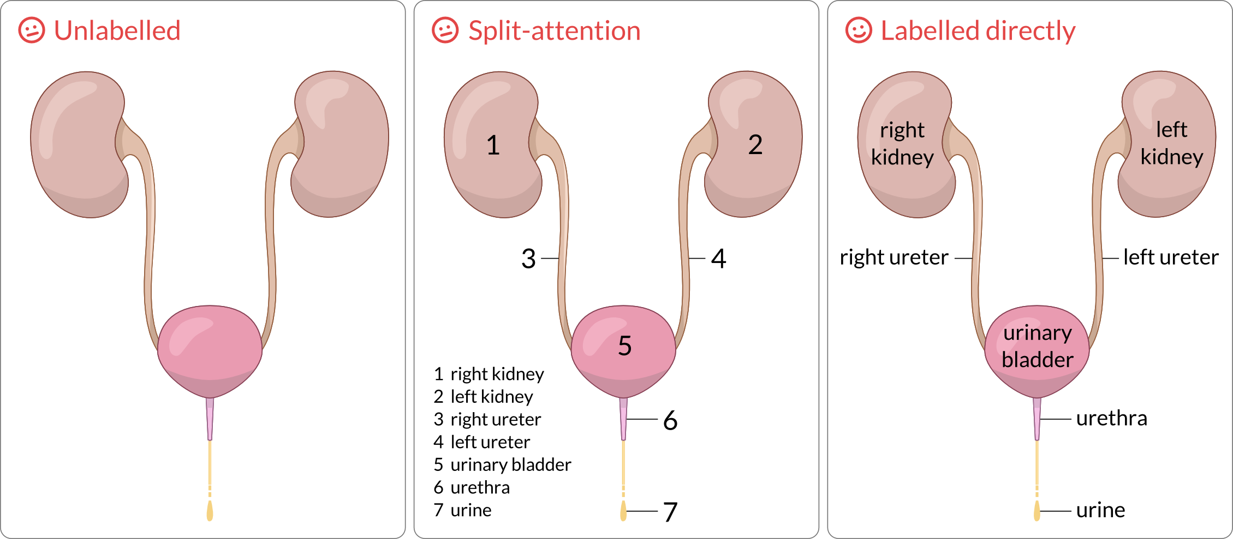
Figure 1. (Learning objective: Identify the parts of the urinary system.) (Left) Unlabelled diagrams are not ideal because it is not clear what specific information students are supposed to learn just by looking at the diagram alone. (Middle) Labelling the diagram with numbers or other symbols with a legend can be useful in certain situations, such as space constraints or too much clutter with the diagram and text. However, the need to refer between the diagram and the legend is a form of split-attention. (Right) The preferred way to label is placing the text labels directly into the diagram.

Interestingly, depending on the subject matter, the placement of labels is not trivial. Chinese writing is in the form of characters (glyphs) with pronunciations that are memorized but initially learned as pinyin (phonetics). Placing pinyin above each character is better for learning than the sequential placement of characters followed by pinyin (Ayres & Sweller, 2021) (Figure 2). By placing pinyin above (or perhaps below) each character, spatial contiguity is established when there is proximity between pinyin and character. However, the sequential placement requires the learner to take additional steps to search and associate mentally the character with the pinyin.

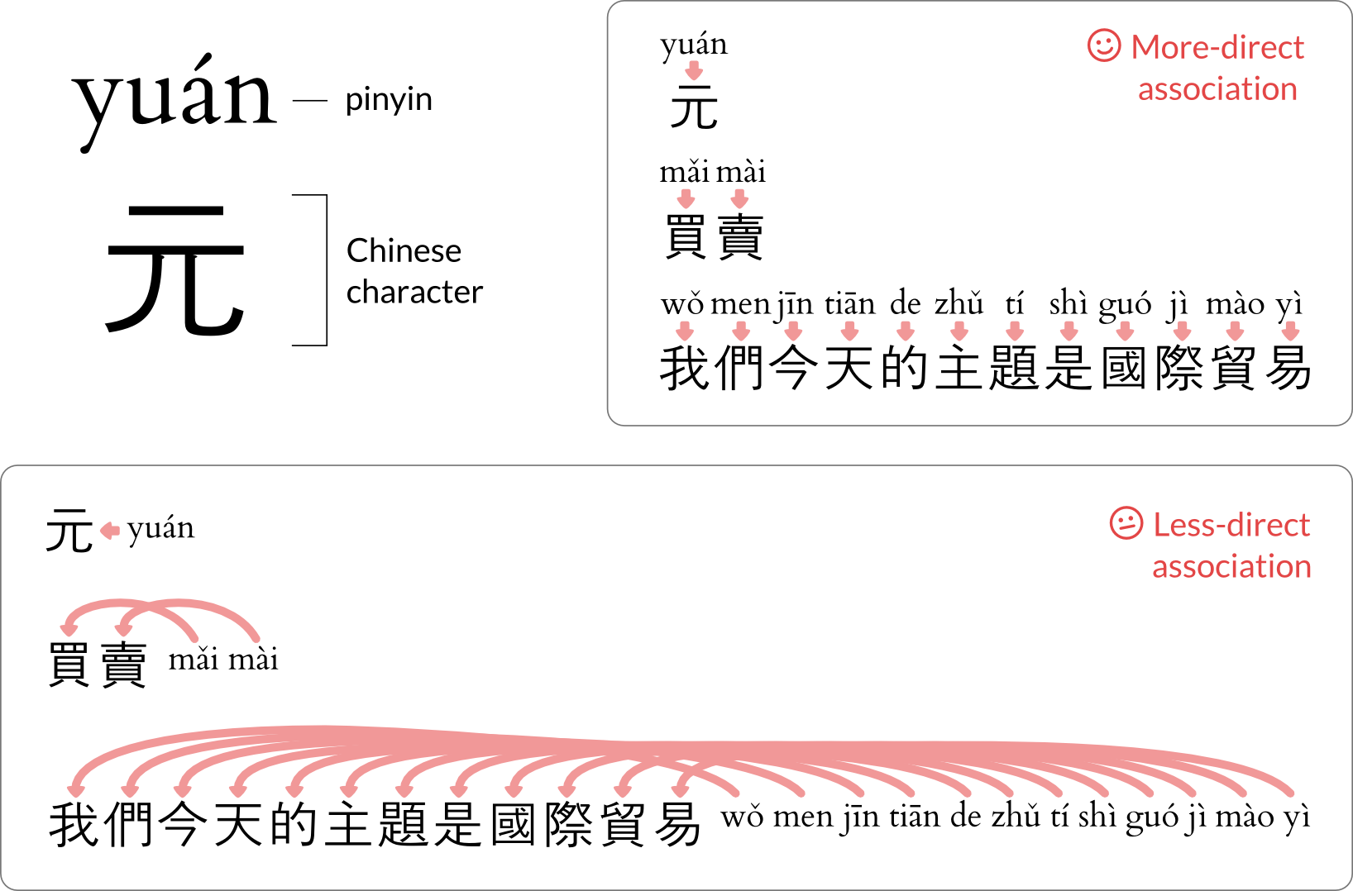
Figure 2. (Learning objective: Read aloud Chinese writing.) Pinyin is a phonetic system to learn the pronunciation of Chinese characters. The arrows denote the mental association in each pinyin-character pair. Displaying pinyin above each character (more-direct) brings pinyin in close spatial proximity to the characters and is more convenient to make the mental associations than displaying pinyin after the phrase of characters (less-direct). Especially with longer phrases, searching for the correct pinyin-character pairs to make the associations takes more mental effort and time. Intersecting arrows denote chances of mental confusion and making the wrong association. Here, the Chinese characters and their meanings are 元 (Chinese unit of currency), 買賣 (buy sell), and 我們今天的主題是國際貿易 (our topic today is global trade).

In geometry lessons, there is a potential for split-attention when segregating the calculations from the image (Figure 3) in a worked example (Ayres & Sweller, 2021). The viewer’s attention shifts repeatedly between the triangle and the calculations in order to see where the calculations fit within the context of the triangle.

Instead, try displaying the calculations near the relevant part of the image. The calculations in Figure 4 are located close to the angle or side of interest. Admittedly, space constraints may limit how close the calculations can be to the image without the overall picture looking awkward.
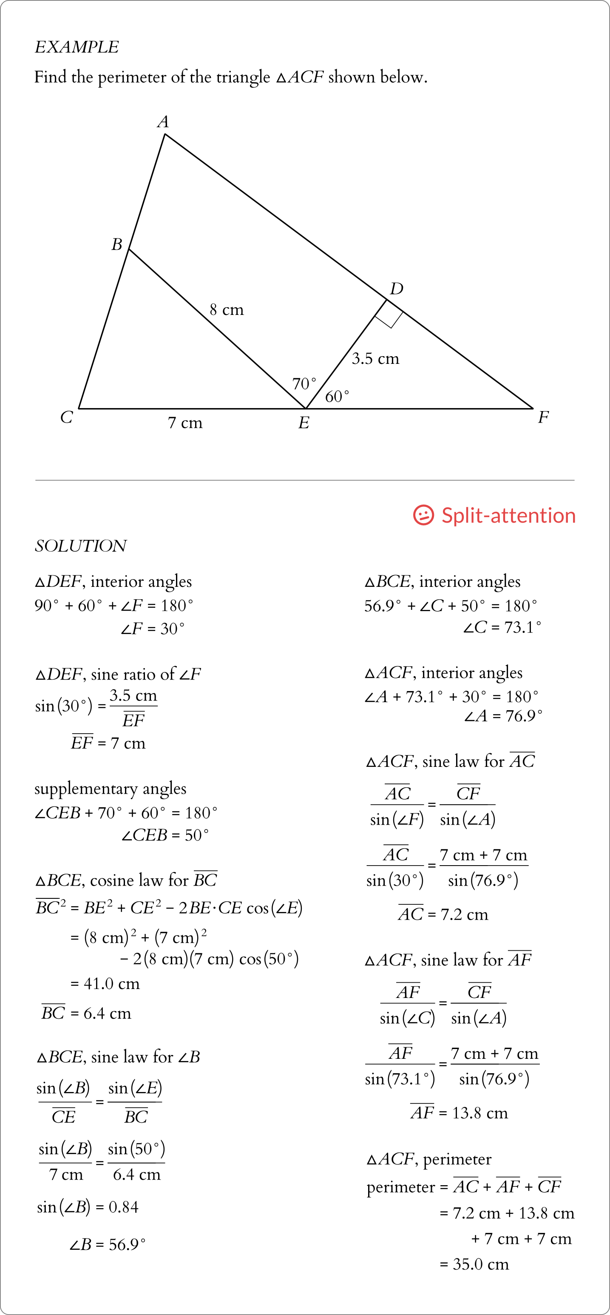
Figure 3. (Learning objective: Apply trigonometric ratios, the sine law, and the cosine law to solve for unknown angles and sides of triangles.) In this worked example, there is a chance of split-attention when spatially separating the calculations from the image of the triangle.
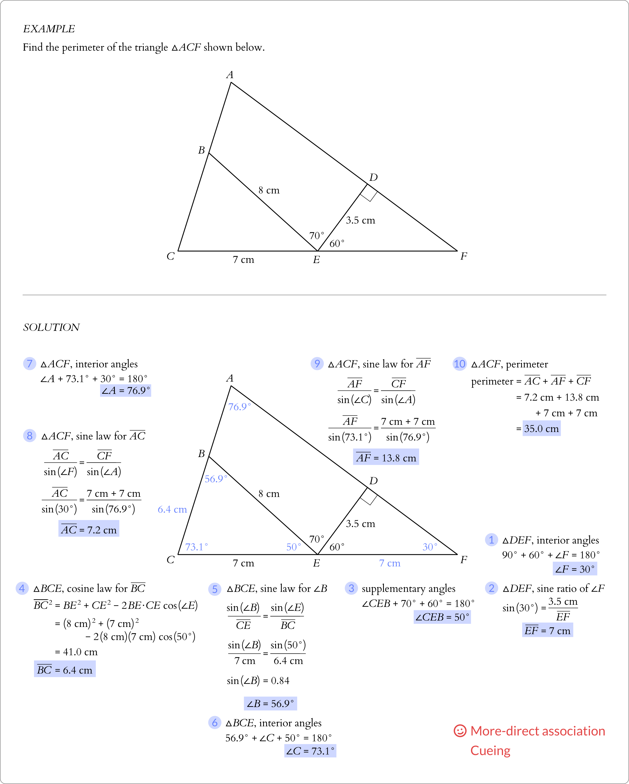
Figure 4. (Learning objective: Apply trigonometric ratios, the sine law, and the cosine law to solve for unknown angles and sides of triangles.) To minimize split-attention between the triangle and each calculation, the triangle in the question is redrawn in the solution field, and each calculation is placed near the angle or side of interest. The sequence of calculations is cued numerically. The solutions are highlighted by colour and visual tone in both the calculations and the triangle.

The Cueing (Signalling) Principle
Implementing cues is another way of improving communication through images. As per the cueing (signalling) principle (van Gog, 2021), cues assist the viewer in interpreting an image by guiding the viewer’s attention to the relevant aspects of the image or to organize the information in the image.

Cues can take on multiple forms, including:

- colour-coding
- tonal variation (light versus dark, greyscale)
- sequencing by numbers or letters
- connectors (lines, arrows, etc.)
- text appearance (monospace, serif/sans serif, bold, italic, underline, etc.)

For viewers who cannot see colour, an alternative to colour-coding is shading (tonal variation). However, even with colour-coding, there may be differences in tone without the need to see colour. Use the greyscale option on an image editing software to check visually whether the colour-coding or shading scheme has sufficient contrast to be discernable.

The same worked example from Figure 3 now has a revised solution (Figure 4) that has numbers to cue the sequence of calculations to solve the question. The sequence is important because the solutions from previous steps are necessary for the calculations in subsequent steps. Without cues, showing all the calculations simultaneously on a page may overwhelm and confuse the learner because it is not obvious how to start solving the problem and which steps to take next. Additionally, solutions from the calculations are shaded and plotted directly into the triangle but in a different colour and tone to distinguish from the values that are given originally in the problem.

While cueing is useful to integrate text and image, cues can also be used within blocks of text, which can be seen in lessons about computer coding. The monospace typeface denotes words that the student should interpret as computer code, Figure 5. Moreover, computer code can be colour-coded manually by the course developer or automatically by the integrated development environment (IDE) to assist in interpreting the code visually.

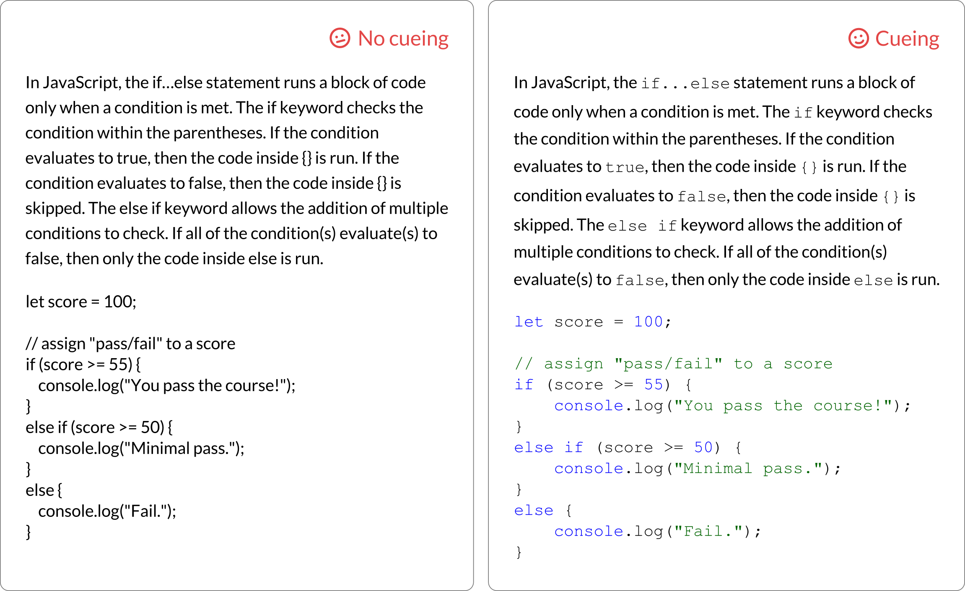
Figure 5. (Learning objective: Write a script with if…else statement.) A paragraph that explains how to write in JavaScript computer code is followed by a sample block of code. Two versions of the text are shown for comparison. The left panel is written entirely in a single typeface and in black text. The right panel has text in a monospace typeface to signal to the reader that the text is referring to computer code and should not be interpreted according to English language rules. In the block of code, keywords and numbers are in blue, and strings and comments are in green.

Emotional Design
A fun aspect of course development to think about is emotional design. The rationale is that positive emotions can improve memory and attention (Derryberry & Tucker, 1994; Isen et al., 1978) and enhance problem-solving, negotiation, and decision-making (Isen et al., 1987). In one study about a lesson on immunizations, round shapes and warm colours improved comprehension and transfer compared to square shapes and neutral colours (Um et al., 2012). Thus, students seem to react positively to images with round shapes and warm colours.

Summary
- Place images close to where the images are referenced in the main text.
- Add labels to images to highlight the relevant information.
- Enhance the readability of images and text with cues, such as numbers, colour, tone, connectors, and text appearance.

Media Attributions
Unless otherwise noted, all figures were created by Jung-Lynn Jonathan Yang under a CC BY-NC-ND 4.0 license.

References
Ayres, P., & Sweller, J. (2021). The split-attention principle in multimedia learning. In R. E. Mayer & L. Fiorella (Eds.), The Cambridge handbook of multimedia learning (pp. 199–211). Cambridge University Press.
Derryberry, D., & Tucker, D. M. (1994). Motivating the focus of attention. In P. M. Niedenthal, & S. Kitayama (Eds.), The heart’s eye: Emotional influences in perception and attention (pp. 167–196). Academic Press.
Fiorella, L., & Mayer, R. E. (2021). Principles for reducing extraneous processing in multimedia learning: Coherence, signaling, redundancy, spatial contiguity, and temporal contiguity principles. In R. E. Mayer & L. Fiorella (Eds.), The Cambridge handbook of multimedia learning (pp. 185–198). Cambridge University Press.
Isen, A. M., Shalker, T. E., Clark, M., & Karp, L. (1978). Affect, accessibility of material in memory, and behavior: A cognitive loop? Journal of Personality and Social Psychology, 36(1), 1–12. https://doi.org/10.1037/0022-3514.36.1.1
Isen, A. M., Daubman, K. A., & Nowicki, G. P. (1987). Positive affect facilitates creative problem solving. Journal of Personality and Social Psychology, 52(6), 1122–1131. https://doi.org/10.1037/0022-3514.52.6.1122
Mayer, R. E. (2021). The multimedia principle. In R. E. Mayer & L. Fiorella (Eds.), The Cambridge handbook of multimedia learning (pp. 145–157). Cambridge University Press.
Um, E., Plass, J. L., Hayward, E. O., & Homer, B. D. (2012). Emotional design in multimedia learning. Journal of Educational Psychology, 104(2), 485–498. https://doi.org/10.1037/a0026609
van Gog, T. (2021). The signaling (or cueing) principle in multimedia learning. In R. E. Mayer & L. Fiorella (Eds.), The Cambridge handbook of multimedia learning (pp. 221–230). Cambridge University Press.

#Anatomy #Biology #Computer science #Cueing principle
#Foreign language #Geometry #Image #Spatial contiguity principle

