Immersive Media

OTHER MEDIA

Updated on December 7, 2024

When used to describe media, immersion is the replacement of physical reality with virtual reality (Cummings & Bailenson, 2016), and educational media have varying levels of immersion (Figure 1). Immersive learning is advantageous for simulating situations that are physically impossible, counterproductive, too dangerous, or too expensive in the real world (Bailenson, 2018; Johnson-Glenberg, 2019; Makransky et al., 2020).

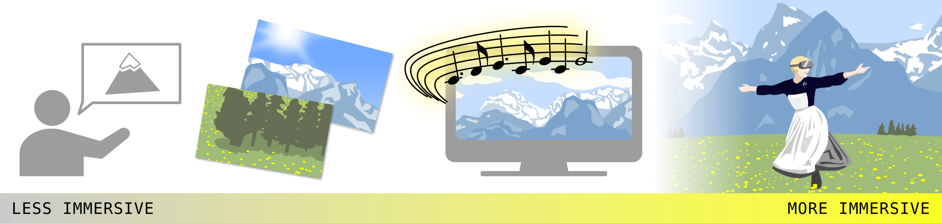
Figure 1. Immersion lies on a spectrum, ranging from less immersive media, such as lecture, static images, and audio-video, to more immersive media, exemplified by virtual reality.

Augmented reality is another form of immersive media that deliberately keeps aspects of the physical reality to serve as points of interaction with virtual reality. A potential application of augmented reality in learning is to present information in real-time during a laboratory experiment (Ayers & Sweller, 2021).

The unique qualities of novel, immersive virtual environments, combined with multimedia design principles, is an approach to improve learning, summarized as the immersion principle (Makransky, 2021).

Advantages and Disadvantages of the Immersion Principle
A highly immersive form of media is virtual reality, which has unique strengths as an educational medium and may be fun to experience (Makransky, 2021). Indeed, highly immersive environments have several applications for learning, such as integrating visual and spatial information, psychomotor skills (head movements for visual scanning), and affective skills (controlling emotional response in stressful situations) (Jensen & Konradsen, 2018).

However, virtual reality is not necessarily more effective than less immersive forms of learning. For declarative knowledge, the effects of immersive simulation were not significantly different than those of learning from desktop simulation or booklet (Makransky, Borre-Gude, & Mayer, 2019) or lecture-based learning (Snelson & Hsu, 2020; Webster, 2016). Some studies even demonstrate that immersive simulation was less effective for learning than conventional media (Makransky, Terkildsen, & Mayer, 2019; Moreno & Mayer, 2004; Parong & Mayer, 2018).

Virtual reality may be counterproductive to learning because of cybersickness, technological malfunction, or the distractions of the immersive experience that detract from the learning tasks (Jensen & Konradsen, 2018). Other considerations before implementing virtual reality in the classroom are the financial cost for students and instructors to access equipment and software as well as the ease of which instructors are able to program virtual environments.
Thus, immersive media has advantages for learning but also has limitations, and similar learning outcomes may be accomplished with media that are less immersive.

Summary
- Currently, there is no convincing evidence to relate the extent of immersion to better learning outcomes.

Media Attributions
Unless otherwise noted, all figures were created by Jung-Lynn Jonathan Yang under a CC BY-NC-ND 4.0 license.

References
Ayres, P., & Sweller, J. (2021). The split-attention principle in multimedia learning. In R. E. Mayer & L. Fiorella (Eds.), The Cambridge handbook of multimedia learning (pp. 199–211). Cambridge University Press.
Bailenson, J. (2018). Experience on demand: What virtual reality is, how it works, and what it can do. Norton & Company.
Cummings, J. J., & Bailenson, J. N. (2016). How immersive is enough? A meta-analysis of the effect of immersive technology on user presence. Media Psychology, 19(2), 272–309. https://doi.org/10.1080/15213269.2015.1015740
Jensen, L., & Konradsen, F. (2018). A review of the use of virtual reality head-mounted displays in education and training. Education and Information Technologies, 23, 1515–1529. https://doi.org/10.1007/s10639-017-9676-0
Johnson-Glenberg, M. C. (2019). The necessary nine: Design principles for embodied VR and active stem education. In P. Díaz, A. Ioannou, K. Bhagat, & J. Spector (Eds.), Learning in a digital world. Smart computing and intelligence (pp. 83–112). Springer.
Makransky, G., Borre-Gude S., & Mayer, R. E. (2019). Motivational and cognitive benefits of training in immersive virtual reality based on multiple assessments. Journal of Computer Assisted Learning, 35(6), 691–707. https://doi.org/10.1111/jcal.12375
Makransky, G., Terkildsen, T. S., & Mayer, R. E. (2019). Adding immersive virtual reality to a science lab simulation causes more presence but less learning. Learning and Instruction, 60, 225–236. https://doi.org/10.1016/j.learninstruc.2017.12.007
Makransky, G., Andreasen, N. K, Baceviciute S., & Mayer R. M. (2020). Immersive virtual reality increases liking but not learning with a science simulation and generative learning strategies promote learning in immersive virtual reality. Journal of Educational Psychology,113(4), 719–735. https://doi.org/10.1037/edu0000473
Makransky, G. (2021). The Immersion Principle in Multimedia Learning. In R. E. Mayer & L. Fiorella (Eds.), The Cambridge Handbook of Multimedia Learning (pp. 296–303). chapter, Cambridge: Cambridge University Press.
Moreno, R., & Mayer, R. E. (2004). Personalized messages that promote science learning in virtual environments. Journal of Educational Psychology, 96(1), 165–173. https://doi.org/10.1037/0022-0663.96.1.165
Parong, J., & Mayer, R. E. (2018). Learning science in immersive virtual reality. Journal of Educational Psychology, 110(6), 785–797. https://doi.org/10.1037/edu0000241
Snelson, C., & Hsu, Y. C. (2020). Educational 360-degree videos in virtual reality: A scoping review of the emerging research. TechTrends, 64, 404–412. https://doi.org/10.1007/s11528-019-00474-3
Webster, R. (2016). Declarative knowledge acquisition in immersive virtual learning environments. Interactive Learning Environments, 24(6), 1319–1333. https://doi.org/10.1080/10494820.2014.994533

#Immersion principle #Other media

