Giving Feedback to Students

OTHER MEDIA

Updated on December 4, 2024

Feedback is a signal to learners to let them know whether they are on the right track in meeting the course objectives and to correct faulty knowledge. In Open Learning, students have the opportunity to obtain feedback from the instructor as well as from interactive media. Examples of such interactive media are D2L/Moodle-based questionnaires, H5P (embedded in Pressbooks), WeBWorK, and Lyryx.

The advantages of interactive media are the convenience of automating feedback delivery and independence from the spatiotemporal availability of the instructor. Nonetheless, depending on the context, an automated response is not informative to students, and instructor input will be required, such as grading a history essay or critiquing a student’s painting.

Here are several suggestions for providing meaningful feedback to students.

Corrective Versus Explanatory Feedback
Corrective feedback simply states whether the student’s response is correct or incorrect, while explanatory feedback goes into more detail to explain why the student’s response is correct or incorrect (Johnson & Marraffino, 2021). The construction of explanatory feedback comes with a greater cost of time and effort from the instructor than the simpler corrective feedback, but research data generally agree that explanatory feedback is more conducive to learning than corrective feedback (Johnson & Marraffino, 2021).

Explanatory feedback has a positive effect on learning objectives about recognition or recall and an even greater positive effect for application-based learning objectives (van der Kleij et al., 2015). In the case of novice learners, the lack of detail in corrective feedback may seem frustrating and not particularly helpful (Bangert-Drowns et al., 1991; Moreno, 2004). Conversely, feedback with more detailed information was more helpful for learning, especially for students with low prior knowledge – in agreement with the feedback principle (Heckler & Mikula, 2016).

However, providing too much information is not desirable. To conserve the cognitive resources of learners, avoid feedback with information that is not directly related to the learning objectives (Johnson & Marraffino, 2021). Otherwise, the extraneous information will compete with the relevant information (Johnson & Marraffino, 2021). Redundant information in feedback should also be eliminated.

A possibility is to use corrective feedback for correct responses and reserve explanatory feedback for incorrect responses. The assumption is that students who answer correctly do not benefit from further explanation, but students who respond incorrectly need additional help to achieve the right answer. Such can be the case with high-knowledge learners, where the explanatory feedback may contain information they already know, thereby imposing extraneous processing to reconcile the redundant information (Johnson & Marraffino, 2021).

Immediate Versus Delayed Feedback
Another consideration is the timing of the feedback. Immediate feedback, delivered right after a response from the student (Johnson & Marraffino, 2021), can quickly remediate errors to prevent erroneous knowledge from being stored into long-term memory (Anderson et al., 1995; Azevedo & Bernard, 1995; Bangert-Drowns et al., 1991). However, students may develop a habit of relying on immediate feedback rather than thinking for themselves (Schmidt, 1991; Shute, 2008). Students could press all the buttons on an electronic learning activity and get the right answers by repeated guess-and-check or trial-and-error (Johnson & Marraffino, 2021) without understanding why the answers are correct (Zhang et al., 2021). Also, immediate feedback may interrupt the student’s attention (Schmidt & Wulf, 1997) during lengthy tasks.

In contrast to immediate feedback, delayed feedback is delivered after the student submits a series of responses, such as after a learning module or after the whole curriculum (Kulik & Kulik, 1988; Shute, 2008). Moreover, there is a belief that delayed feedback is more effective than immediate feedback in laboratory settings than in application-based contexts (Kulik & Kulik, 1988).

Overall, the effectiveness of immediate versus delayed feedback is dependent on multiple factors, such as the context and learner characteristics (Hattie & Timperley, 2007; Kulik & Kulik, 1988; Shute, 2008).

Feedback Effectiveness
The effectiveness of the feedback also depends on whether students perceive and heed to the advice (Johnson & Marraffino, 2021). Cognitive overload may hamper feedback perception, for example, pairing visual (written words) feedback with a visual task. An alternative is to replace written feedback with spoken feedback (Fiorella et al., 2012). Also, students may ignore feedback, such as in a low-stakes (ungraded) activity, which may explain the similarity in performance in a study where students received either corrective feedback, explanatory feedback, or no feedback (Golke et al., 2015). Students in the study also seemed to be more vested in the task when the feedback was from a person than from a computer (Golke et al., 2015).

Personalized comments from the instructor can be social cues to the student to signal that the instructor is interested in the student’s learning and is holding the student accountable for meeting the learning objectives. The drawback is that personalized comments, unique to each student’s situation, can take more time and effort to write than a one-size-fits-all, automated feedback on interactive media.

When making feedback algorithms on interactive media, the course developer should perform test runs, by inputting correct responses as well as incorrect responses, to make sure the feedback is appropriate. As an example, Figure 1 shows a slight discrepancy between the course reading and the corrective feedback in the H5P exercise. There should be consistency between the information from the course and the feedback given to students.

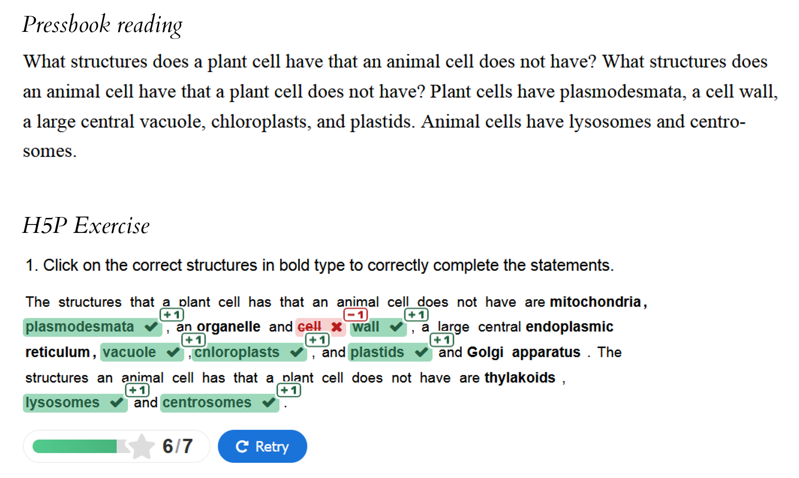
Figure 1. In accordance with the information from the course reading, the H5P exercise (Molnar & Gair, 2015) should accept “cell wall” as a correct response.

The act of giving feedback extends beyond grading assessments and includes the interpersonal interactions between the student and the instructor. These interactions serve to confirm that the learning objectives are being met and, if not, how to improve. The independent, virtual learning environment of Open Learning may lead to students feeling isolated from the instructor and from classmates. Vague and disingenuous feedback could compound the feeling of isolation. If support is not available from the instructor or from course materials, students’ distress may manifest as cries for help on social media (https://www.reddit.com/r/tru/comments/1872zxd/stat1201). As an approach to minimize stress on students, instructors should give meaningful feedback that has specific, concrete advice.

Summary
- The context of the learning activity determines the type of feedback: corrective versus explanatory, immediate versus delayed, and automated versus personalized.
- Ensure learners receive messages that are meaningful and consistent with the information from the course content.

Media Attributions
Unless otherwise noted, all figures were created by Jung-Lynn Jonathan Yang under a CC BY-NC-ND 4.0 license.

References
Anderson, J. R., Corbett, A. T., Koedinger, K. R., & Pelletier, R. (1995). Cognitive tutors: Lessons learned. The Journal of the Learning Sciences, 4(2), 167–207. https://doi.org/10.1207/s15327809jls0402_2
Azevedo, R., & Bernard, R. M. (1995). A meta-analysis of the effects of feedback in computer-based instruction. Journal of Educational Computing Research, 13(2), 111–127. https://doi.org/10.2190/9LMD-3U28-3A0G-FTQT
Bangert-Drowns, R. L., Kulik, C. L. C., Kulik, J. A., & Morgan, M. (1991). The instructional effect of feedback in test-like events. Review of Educational Research, 61(2), 213–238. https://doi.org/10.3102/00346543061002213
Fiorella, L., Vogel-Walcutt, J. J., & Schatz, S. (2012). Applying the modality principle to real-time feedback and the acquisition of higher-order cognitive skills. Educational Technology Research and Development, 60, 223–238. https://doi.org/10.1007/s11423-011-9218-1
Golke, S., Dörfler, T., & Artelt, C. (2015). The impact of elaborated feedback on text comprehension within a computer-based assessment. Learning and Instruction, 39, 123–136. https://doi.org/10.1016/j.learninstruc.2015.05.009
Hattie, J., & Timperley, H. (2007). The power of feedback. Review of Educational Research, 77(1), 81–112. https://doi.org/10.3102/003465430298487
Heckler, A., & Mikula, B. (2016). Factors affecting learning of vector math from computer-based practice: Feedback complexity and prior knowledge. Physical Review Physics Education Research, 12, Article 010134. https://doi.org/10.1103/PhysRevPhysEducRes.12.010134
Johnson, C. I., & Marraffino, M. D. (2021). The feedback principle in multimedia learning. In R. E. Mayer & L. Fiorella (Eds.), The Cambridge handbook of multimedia learning (pp. 403–417). Cambridge University Press.
Kulik, J. A., & Kulik, C. C. (1988). Timing of feedback and verbal learning. Review of Educational Research, 58(1), 79–97. https://doi.org/10.3102/00346543058001079
Molnar, C., & Gair, J. (2015). 3.3 Eukaryotic Cells. In Concepts of Biology - 1st Canadian Edition. https://opentextbc.ca/biology/chapter/3-3-eukaryotic-cells
Moreno, R. (2004). Decreasing cognitive load for novice students: Effects of explanatory versus corrective feedback in discovery-based multimedia. Instructional Science, 32, 99–113.
Schmidt, R. A. (1991). Frequent augmented feedback can degrade learning: Evidence and interpretations. In J. Requin, & G. E. Stelmach (eds.), Tutorials in motor neuroscience (pp. 59–75). Kluwer Academic Publishers.
Schmidt, R. A., & Wulf, G. (1997). Continuous concurrent feedback degrades skill learning: Implications for training and simulation. Human Factors, 39(4), 509–525. https://doi.org/10.1518/001872097778667979
Shute, V. J. (2008). Focus on formative feedback. Review of Educational Research, 78(1), 153–189. https://doi.org/10.3102/0034654307313795
van der Kleij, F. M., Feskens, R. C., & Eggen, T. J. H. M. (2015). Effects of feedback in a computer-based learning environment on students’ learning outcomes: A meta-analysis. Review of Educational Research, 85(4), 475–511. https://doi.org/10.3102/0034654314564881
Zhang, S., de Koning, B., Agostinho, S., Tindall-Ford, S., Chandler, P., & Paas, F. (2021). The cognitive load self-management principle in multimedia learning. In R. E. Mayer & L. Fiorella (Eds.), The Cambridge handbook of multimedia learning (pp. 430–436). Cambridge University Press.

#Biology #Feedback principle #Other media

